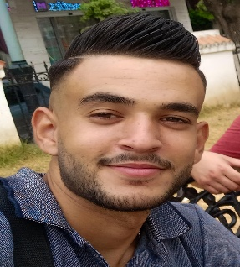**Zitoun Ramzi**

**Level**: Terminale

**Diploma**: Senior marketing technician

**Telephone number:** 0782 88 53 38

**Address**: Cité dahdouh mouhamed N =05 didouche morad – Constantine - Algeria

**Email**: [ramzizitouni979@gmail.com](mailto:ramzizitouni979@gmail.com)

**MARITAL STATUS**

**Date and place of birth**: 08/05/2001 in Constantine

**Family status**: single

***Algerian nationality***

**Driving license**: light category (B)

**Experience**

* November 2020 – May 2023: 2 years and 7 months experience as a medical equipment driver in the company SARL PHARMAXIS SURGICAL
* June 2023 – December 2023: 7 months experience as a medical equipment seller in the company SARL PHARMAXIS SURGICAL
* May 2024 – June 2024: 2 months production experience in the company Physiopharm

**Language**

**Arabic**: mother tongue / **French**: medium / **English**: medium

**Personal characters**

Mastery of IT tools, punctual, serious, dynamic, team player with a sense of responsibility, innate sense of organization and communication