ALI EHSAN 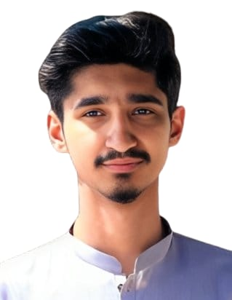
CONTACT: 0092333-6754140
Profession : LAND SURVEYOR
Current Location : PAKISTAN
Email Address: : Aehsan1214@gmail.com
FATHER’S NAME : AMJAD ALI (LATE)
DATE OF BIRTH : 24-9-2004
PASSPORT NO. : BF4195382
NATIONALITY : PAKISTANI
CONTACT NO. : 00923336754140
ADDRESS : House No 418, Street 2-A, Phase 4-b Ghauri Town Islamabad .

Professional profile

- RESULTS-DRIVEN PROFESSIONAL. Highly organized, efficient, Flexible to work anywhere irrespective of locations, environment & weather conditions. Dedicated and committed willing to take on challenging roles & tough assignment; able to deliver the job meeting deadlines. Additional expertise includes;
- experience on variety of surveying equipments with different technologies and features.
- Total station, Theodolite, Auto Levels

Objective

To learn and excel with a commitment towards the achievement of organization’s objectives by carrying out my duties responsibly while maintaining excellent interpersonal relationships thus giving a bottom line impact.
POFESSIONAL SKILLS

- Good team WORKER and can motivate people also to perform specified tasks.
Able to represent company with professional appearance Languages

EDUCATIONAL PROFILE
1. Diploma of Associate Engineering (civil) at Askari Institute of Technology Rawat Islamabad Pakistan .
2.Matriculation (Science) from Board of FBISE Islamabad Pakistan.

PROFESSIONAL EXPERIENCE
Position LAND SURVEYOR

COMPANY:- BLUE BRICK ARCHITECT AND CONSULTANT.
Projects
BLUE BRICKS is a leading provider of comprehensive land surveying and geospatial services, known for our commitment to precision, innovation, and client satisfaction. With a strong track record in the industry, we specialize in offering a wide range of surveying solutions, including Boundary Surveys, Topographic surveys And Construction staking.
During my tenure as a land surveyor at BLUE BRICKS, I was responsible for conducting detailed site assessments, utilizing advanced surveying equipment and technologies to ensure accurate data collection and analysis. My role involved collaborating closely with engineers, architects, and project managers to deliver reliable and timely surveying solutions that supported the successful execution of various construction and development projects.

From 2023 to 2024.
Position LAND SURVEYOR

COMPANY:- HABIB RAFIQ LLC.
Projects
HRL is currently working in development of Capital Smart City At Chakri road RAWALPINDI PAKISTAN .I am working As a Land Surveyor, my core activities include: Have Work Experience for Different Infra- Structures Including Roads, Sewerage Bed Preparations etc.
Conduct field surveys to gather data on land boundaries, topography, and other physical features.
Keep accurate records of survey data and maintain equipment.

From 2022 to 2023.
2. Employment Position ASSISTANT SURVEYOR
Company :- BKC contractor (Internship) 2020 to 2022.

Thanks to Badsha Khan company that they give a chance to learn professional skills during my education and after with their dedicated team On their Road projects.
From 2020 to 2022
. Responsibilities managing in surveying
- Topographic Survey of the project site.
- Roads Excavation & Foundation Level Survey
- Detailed Survey for undertaken Demolition Plan
- Coordinate with Design Section for Preparation of Shop Drawings
- Land Survey for Irrigation Work & Land Survey for Soft Landscaping and Hard Landscaping Works
- Coordination with Consultant for Inspection Purposes.
- Buildings Substructure, Super Structure and Finishing Schedule all related surveying works and coordination with the Engineers during execution.
- Coordination with Design Section for Preparation of Shop Drawings
- Coordination with Consultant for Inspection Purpose
- Layout of Sewerage and Drainage Pipeline & Observation of Cross-Section.
- Calculating and fixing of invert of Drainage and Sewer pipelines & Control of Layers.
- Design work for house connections and cover level for chambers and main holes.
- Roads & infrastructure works with underground utilities, cabling, pipelines etc
- Earthworks including excavation/backfilling, utility foundations etc.

