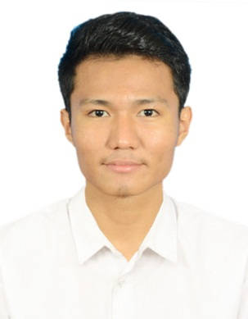‘`````````

MR. SANDA KYAW

Certificate in Toyota Technician

Certificate in Pro Technician (Team 21)

Certificate in Diagnosis Technician (Electrical)

Certificate in Diagnosis Technician (Chassis)

Certificate in Pro Technician (Team – GP)

+66990631622

[Sandakyaw29@gmail.com](mailto:Sandakyaw29@gmail.com)

Service Technician

Education

Passport No : MG298149

Nationality : Myanmar

Native : Yangon

Date of Birth : 2nd Sep 1997

Gender : Male

Marital Status : Single

Higher National Diploma (HND) in Mechanical Engineering

UMG College Myanmar

2013 – 2017

Expertise

* Problem Solving
* Collaboration
* Strong work Ethic
* Time Management
* Flexible

Technical Training

Bang Kapi, Bangkok, Thailand

Personal Information

**Senior Service Technician**

**Leapmotor Myanmar Co.Ltd | Yangon | From 2023 To 2024**

Linkedin.com/Sanda Kyaw

in

Career Objective

Motivated Service Technician with a strong background in diagnostic and repair services. Aiming to utilize my hands-on skills and certification to deliver exceptional vehicle maintenance and enhance customer satisfaction.

Professional Experiences

Assist to the Service Manager for opening the service center and prepare the service tool and other necessaries for service area. Check and manage the lift installation process and alignment lift. Check and make the PDI inspection before deliver to the customer. Check the periodical maintenances (PM) that is giving service the vehicle (in accordance to used kilometer). Give the diagnostic services by scan tool and repair manual.

**Service Technician**

**Toyota Mingalar Co.Ltd | Yangon | From 2018 To 2023**

Learned about the turbos and analyzed the nozzle which it designed by BOSCH. Disassembled the engine (especially VOLVO) for test to service and assembled the engine after servicing and test-run the engine for outlet. Operated the CNC machine and served at the machining section. (welding, cutting and surfacing the material). Disassembled the hydraulic components which is the parts of back hole. Serviced the hydraulic components. Latest portion of this job is assembly the whole body of the Volvo backhoe and test – run that vehicle.

Check and make the inspection for the New Car (Pre-Delivery Inspection) before deliver to the customer. Check the periodical maintenances (PM) that is giving services the vehicle (in accordance to used kilometer). Carry out the GR (General Repair) and overhaul inspection such as engine, transmission, brake and etc. Give the diagnostic services by scan tool and repair manual. While Toyota technician life, they provided the training which is systematically and according with my level that is step by step. Training lessons are applied in diagnostic and wiring work effectively and get the customers satisfactions.

**Mechanical Engineer (Intermship Training )**

**Chrysanthemum Wealth Co.Ltd (UMG Group of Companies)| Yangon | 3 months Training Program**