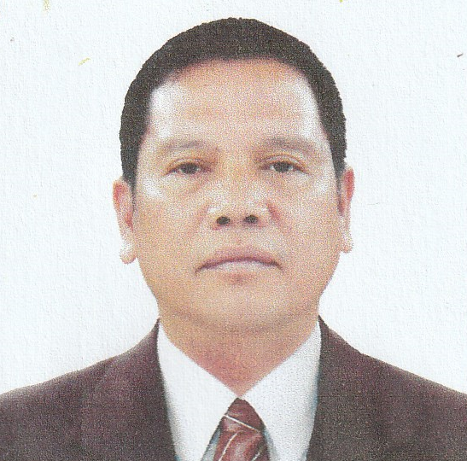
Arlan Zabaceda Loberio
18 ME Herta Road Ilayang Iyam
Lucena City,Quezon 4301
Cell NO.+639395524237
+639276532425
e-mail: arlanloberio738@gmail.com

Objective:
To find employment to a company in which I can utilize my exceptional skills and extensive background that will contribute to a company culture and helps the company to increase productivity scores.

PERSONAL DATA :

Age : 51 yrs. old
Date of Birth : September 1, 1972
Place of Birth : Lucena City
Citizenship : Filipino
Civil Status : Married
Sex : Male
Religion : Iglesia Ni Cristo
Height : 5’4”
Weight : 160 lbs.
Father’s Name Jaime Loberio
Mother’s Name : Myrna Zabaceda
EDUCATIONAL BACKGROUND

School Degree Dates
Lucena West I Elementary School Primary 1985
Quezon National High School Secondary 1989
Manuel S.Enverga University Tertiary 2001

EMPLOYMENT RECORD

Sept. 04,2002-Sept.15,2004 Balibago Transport Services
Transport Driver
Sta Rosa, Laguna/ Philippines

Aug. 03,2010-July 03,2015 Saudi Anfal for Automatic Doors Co.
Fabricator
Saudi Arabia,Riyadh KSA

Duties and Responsibilities:
Fabricating of some parts which are needed to have a good performance doors.

December 08,2012-september 2015 Saudi Anfal for Automatic Doors Co.
Driver/ Technician
Saudi Arabia Riyadh KSA
Duties and Responsibilities:
installation of automatic doors and maintaining it’s performance to ensure and protect the name of the business.

July 2016-June 2021 Balibago Transport Services
Transport Driver
Sta Rosa Laguna/ Philippines

September 2021-No. 2023 AlDar Automatic Doors
Driver Technician
Doha Qatar

SPECIAL SKILLS

Driving Vehicle
Repairing Minor Trouble in 4 Wheel Vehicle
Knowledgeable of using Arc Welding(SMAW)
Can understand Current Resistance

SEMINARS ATTENDED

March 4, 2009-July 6,2009
TESDA (Technical Education Skills Development Authority)
CES- Consumer Electronics Servicing
Accomplishment: FULL NC II

Oct. 7,2009- Dec. 15,2009
LMSTC (Lucena Manpower Skills Training Center)
SMAW (Shielded Metal Arc Welding)

I hereby certify that the above information is true and correct to the best of my knowledge and belief

ARLAN ZABACEDA LOBERIO

