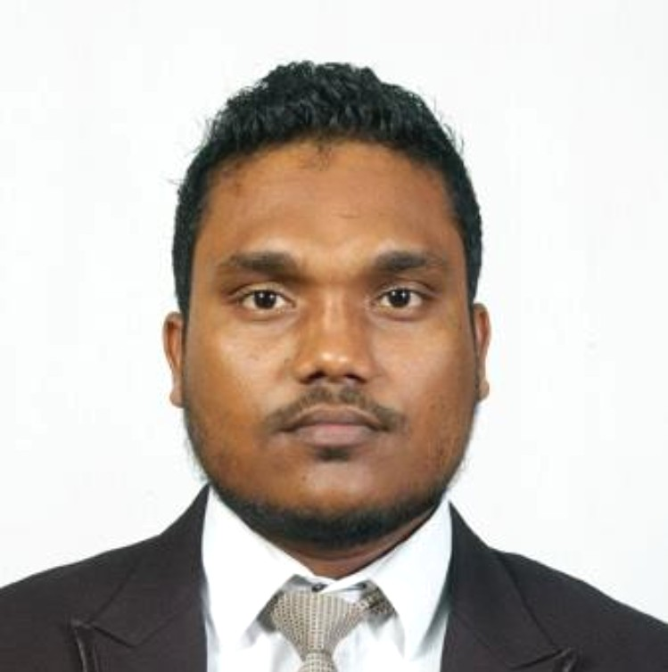

ASANKA

PUSHPA KUMARA

DRAUGHTPERSON

**PERSONAL INFO**

**Age** : 31 years

**Date of Birth** : 28th Nov 1991 **Nationality** : Sri Lankan **Civil Status** : Single

**Gender** : Male

**KEY SKILLS & COMPETENCIES**

**Communication Skills Problem Solving Critical Thinking Interpersonal Skills**

**Time Management**

**CONTACT ME AT:**

+974 70440034 | +94 770045450

[aluthgamagekumara@gmail.com](mailto:aluthgamagekumara@gmail.com)

172/1, Cemetery Rd, Thalapathpitiya, Nugegoda, Sri Lanka.

# CAREER OBJECTIVE

I am an ambitious, dedicated and hardworking person with the ability of accomplishing my tasks and responsibilities. My enthusiasm is to enhance my knowledge by practicing new territories and technologies in the field of Civil Draughting. Honesty, reliability, punctuality and capability of working with people are several of my humanitarian qualities prevailing. I am looking forward to render my service to a leading business organization to utilize my knowledge and skills for the betterment of it.

# WORK SUMMARY

## Qatar Building Company (Road Section)

**Draughtperson** | Dec 2019 - Present

Worked as civil draughtsman such as preparing civil engineering drawings & Preparing detailing shop drawing. Road marking shop drawings. (highways, local roads) Asphalt shop drawings for local roads.

Preparing (TDP) traffic diversion planning drawings for highway maintenance project.(Qatar Ashghal) Project Number ( ZF_087)

Qatar building Company Sinage Section Designer.

Preparing super imposed drawing for highway maintenance & Street Lighting project (Qatar Ashghal )

Working in FIFA World Cup 2022 Project. (Stadium Signage & Road Signage )

Qatar “Al Aresh “ Road Construction Project Draughtsman

Project Number ( ZF_066) Started at (2023).

## Star Design Solutions Ltd - UK

**Junior Engineer** | May 2018 - Nov 2019

Worked under Managing Director after promoted as Junior

Engineer.

Designed & calculated steel & timber for loft conversions, rear extensions, first floor extensions & basements of UK houses & buildings.

Detailed the structural layout & roof plan. Calculate steel structure & timber structure.

## Star Design Solutions Ltd - UK

**Senior Draughtsman** | May 2014 - Nov 2018

Worked under Managing Director as Senior Draughtsman. Design for loft conversions, rear extensions, first floor extensions & basements of UK houses & buildings.

Detailed the structural layout & roof plan. existing asbuilt drawing.

Proposed drawing for uk standard architectural houses. Section detailing .

Detailing drawing.

**SOFTWARE PROFICIENCY**

**MS Office Package**

**AutoCAD**

**ProSteel 5**

**SuperBeam 4**

**3D Max**

**Adobe Illustrator**

**LANGUAGE SKILLS**

English

85%

Sinhala

99%

**REFERENCE**

To be provided upon request

## Well Seen (pvt) Ltd. (Architecture Firm)

**Architectural Draughtsman** | May 2012 - May 2014 Worked as Architectural Draughtsman Such As Making Architectural DWG & Making Detailing Drawing.

Proposed building houses drowning, Existing building surveying, council drawing, Construction site visit, Settling out.

# ACADEMIC QUALIFICATIONS

### The Ceylon Germen Technical Training Institute

**Diploma in Civil Draughtsman Ship |** 2011

### Lalith Athulathmudali Technical Training Institute

**Certificate in Quantity Surveying |** NVQ L4 **|** 2015

### Lalith Athulathmudali Technical Training Institute

**Certificate in 3D max & Auto Cad |** 2012

### Horizon Education Center

**Certificate Course in Illustrator |** 2020

### ICBT Campus

**Higher Diploma in Quantity Surveying |** 2023.

### Lalith Athulathmudali Technical Training Institute

**Certificate in Auto desk Revit (Architecture & MEP) |** 2024

**EXTRA CURRICULAR ACTIVITIES**

Acted as a member in the organizing committee of Open day Events & Exhibitions held to commemorate 30th Anniversary of The Ceylon Germen Technical Training Institute of Srilanka.

Hiking mountains Kirigalpotta (2,395 m) & Knuckles (1,863 m) till summit.

Member of the welfare society.

# DECLARATION

”I hereby declare that the given information is true and correct to the best of my knowledge and belief.“

A.A.P. Kumara. 22/09/2024