**RESUME**

**Bishowmani Dahal Mobile: +974 71806768**

Forklift Technician

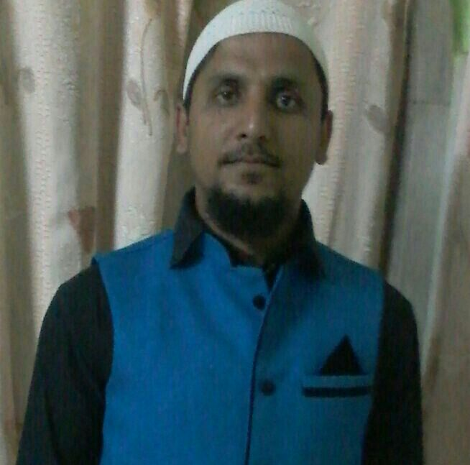

Sajid Ali

##### Summary

##### Results-driven Forklift Technician with 17+ years of experience in maintaining and repairing forklifts. Strong ability to communicate and collaborate effectively with team members to troubleshoot and resolve complex technical issues. Proficient in conducting inspections, implementing preventative maintenance measures, and ensuring compliance with safety protocols. Dedicated to optimizing equipment functionality and minimizing downtime. Certified in forklift maintenance and industrial safety. Accomplishments include implementing efficiency initiatives resulting in a 30% reduction in downtime and receiving a Safety Excellence Award for promoting workplace safety.

##### PERSONAL PROFILE:

##### I have around 12 years excellent professional experiences in automobile industry as a technician cum electrician, involving all battery related technical works and have always performed my duties to the utmost satisfaction of my superiors. I prefer to take challenges and responsibilities.

**WORK EXPERIENCES:**

**Position**: Senior Technician

**Duration:** Nov 2020 to till July 2022

**Company**: Gulf Construction Machinery (Dealer of Hyundai and Wacker Neuson )

**Location**: Industrial Area Street 38, Doha, **Qatar**

**Duties and Responsibilities:**

* Performed troubleshooting and maintenance on various forklift and Equipment systems, ensuring safe and efficient operations within a fast-paced warehouse environment.
* Executed preventative maintenance tasks resulting in a 10% decrease in equipment breakdowns.
* Identified and repaired electrical and hydraulic system issues, reducing downtime by 30%.
* Collaborated with cross-functional teams to implement safety protocols, resulting in a 25% reduction in workplace accidents.
* On site inspections, repair, delivery.

**Past Experience: 1**

**Position**: Forklift Technician

**Duration:** Sep 2009 to till Nov 2020

**Company**: Abdulla Abdulghani Motors (Dealer of Toyota MHE Corporation and Kawasaki Wheel Loader)

**Location**: Doha, **Qatar**

**Duties and Responsibilities:**

* Performed troubleshooting and maintenance on various forklift and Equipment systems, ensuring safe and efficient operations within a fast-paced warehouse environment.
* Resolving technical Issue related to engine/motor Transmission or Material Handling System of Toyota Diesel/Electric/Gasoline forklifts
* Performing Pre-Delivery Inspection, Installation of Mast, attachments and other accessories.
* Commissioning Battery and charger as per PDI check list
* c electrical and hydraulic system issues, reducing downtime by 30%.
* Collaborated with cross-functional teams to implement safety protocols, resulting in a 25% reduction in workplace accidents.

**Past Experience 2**

**Position**: Mechanic (Forman)

**Duration:** Mar 2005 to Mar 2009

**Company**: R & A Commercial Vehicle SND.BHD

**Location**: Malaysia

**Duties and Responsibilities:**

* Performed troubleshooting and maintenance on various type of Trucks, ensuring safe and efficient operations within a fast-paced warehouse environment.
* Executed preventative maintenance tasks.
* Electrical and Body repair
* Identified and repaired electrical and hydraulic system issues,
* Collaborated with cross-functional teams to implement safety protocols, resulting in a 30% reduction in workplace accidents.

**EDUCATION QUALIFICATION:**

Secondary School Leaving Certificate (Nepal)

**PROFESSIONAL QUALIFICATIONS / TRAININGS**

* TMHE step one training completed in 2018
* Service skill training attended in Dubai for Kawasaki Wheel Loader
* Service Skill workshop training conducted by TMHE
* Health and Safety Awareness of Automobile industries (Supreme Council of Health Doha Qatar)
* Good Operator of Forklift, VNA, Reach Truck, Stacker, Wheel Loader, Skid Loader, Roller, and other warehouse equipments.

**Personal Information**

**Date of Birth** : 24th January 1982

**Sex** : Male

**Nationality** : Nepali

**Visa Status** : with valid QID, NOC will be provided

**Languages Knows:** English, Arabic, Hindi, Nepali

**Email ID**: bishowm.bb@gmail.com

**Passport Details**

Passport Number: BA0248990

Expiry Date: 26.08.2033

##### REFERENCE

Will be Provided on Request

**HOBBIES:**

Playing Football, Making Friends, , Photography, Teamwork

##### DECLARATION

I hereby declare that the above-mentioned details are true to the best of my knowledge.