[**CURRICULUM VITAE**](https://www.google.com/url?sa=t&rct=j&q=&esrc=s&source=web&cd=9&cad=rja&uact=8&sqi=2&ved=0ahUKEwi_0KCAyanNAhUHCMAKHVYZCOoQFggxMAg&url=https%3A%2F%2Feuropass.cedefop.europa.eu%2Fen%2Fdocuments%2Fcurriculum-vitae&usg=AFQjCNEHg3et18KYCW4iabFIb17E9a-0eg&sig2=0mb12ZY-ogTCHxq7Z6b6Tw&bvm=bv.124272578,d.bGg)

**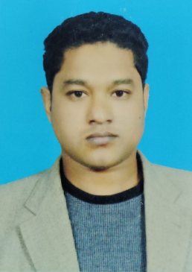  
MD RIAJUL HAQUE   
Doha – State of Qatar.  
Cont. No: +974 – 77599043 Email: rifathhaque2018@gmail.com**

**Career Objective :**“ To contribute the best of my knowledge and skills to became an asset to  
any project and company that will trust on my capability.”

**Profile Summary**   
  
**Nationality**   **:** MD RIAJUL HAQUE

**Civil status** **:** Married

**Current Position** **:** Driver

**Current Location** **:** Doha, State of Qatar

**Visa status**  **:** Employment (Transferable)

**Company**  **:** Central Limousine

**RP Status (Transferable) :** 04.12.2024 (QID No. 28405028428)

**Education Details :**

* SSC – Completed Year 2008 From Annoda Government School.
* HSC – Completed Year 2010 From Brahmanbaria Government College.

**Work Experiences**

* Working with Central Limousine,

Doha - State of Qatar from **December 2022 to still** as a **“Taxi Driver”.**

* Worked with Talabat,   
  Doha – State of Qatar, from **June 2021 to October 2022** as a **“Delivery Man”.**

**Personal Details**

Father’s Name  **:** Md Alamgir   
  
Mother’s Name **:** Mrs. Roji Akter  
  
Native address  **:** Vill: Halder Para, P.S: Sadar,  
 P.O: Brahmanbaria, Bangladesh.  
  
Gender  **:** Male  
  
Date of Birth **:** 10.06.1984  
  
Place of Birth  **:** Brahmanbaria  
  
Passport No  **:** EM0401742  
  
Sponsor **:** Central Limousine  
  
Driving License **:** Available (Car & Bike)

Languages Known **:**  English, Hindi & Arabic (Little)

**Certification:**

→ I honestly certify that the given statements and presentation are true, correct   
and the best of my knowledge, this CV faithfully made for better opportunities for  
personal challenge and demand.

**MD RIAJUL HAQUE**  
Doha – State of Qatar.