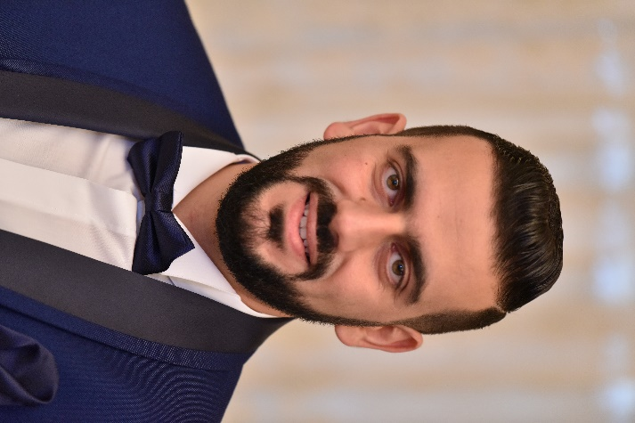 |  | fIRAS DACCACHE
Profile  Manufacturing and industrial experts, worked as Operations Manager, Technical sales engineer, Teacher, Trainer, Production supervisor and CNC Machinist.  Contact  PHONE:  +961 71 523023  LINKEDIN:  https://www.linkedin.com/in/firas-daccache-00982617/  EMAIL:  firasdaccache@gmail.com  LANGUAGEs  ENGLISH  ARABIC  FRENCH  KEY SKILLS AND CHARACTERISTICS  Budget Management  Excellent listener  Able to Inspire and Motivate  Decision Maker  Problem solver  Strategic Thinker  Friendly, courteous, and service oriented  Poised under pressure  Technical Training & Coaching  Recruiting and Hiring Talent  Solid written and verbal communicator |  | WORK EXPERIENCE  Operations Manager – Technical sales engineer,  Raymond Feghali Machinery and Tools sarl, Beirut, Lebanon  2014–Present  Supervise the company’s staff; Organizing sales visits; Training presentations to help clients discover and understand products and services; Preparing tenders, proposals and quotations; Providing pre-sales and post-sales support; Assembly, Installation, commissioning and training on different CNC machines with different controllers (Fanuc, Siemens...); Attending trade exhibitions, conferences; Sales and training on: Vertical machining centers, CNC Turning, CNC fiber laser, CNC routers, CNC Hydraulic Press brakes, Hydraulic shears; Expertise with all accessories and cutting tools.  Teacher  Technical Institute of Eddeh, Jbeil- Lebanon  2013–Present  Teaching level of higher technician in mechanics (TS)  Teaching: AutoCAD 2D &3D; Solidworks, SolidCAM, CNC Milling & Turning,  Production supervisor  Sototoles, Lomé-Togo.  2011–2013  Supervising and Maintenance of production lines : Galvanization Unit- Production unit for rebar and annealed wires- Welded tube production unit (Round, square, rectangular, etc.)- Nail production unit- Flat iron production unit.  CNC Machinist (2008-2011)  Phoenix Machinery, Safra-Lebanon.  CNC Milling & Turning; Controller Fanuc, Num, Sinumeriks, Heidenhain  Programming- Quality Control – Supervising and managing CNC operators- Troubleshooting and fixing mechanical issues.  EDUCATION  License of Technical Education (LET) in Mechanical Production at: National Pedagogical institute of Technical Education.  IPNET – Beirut year of 2009

