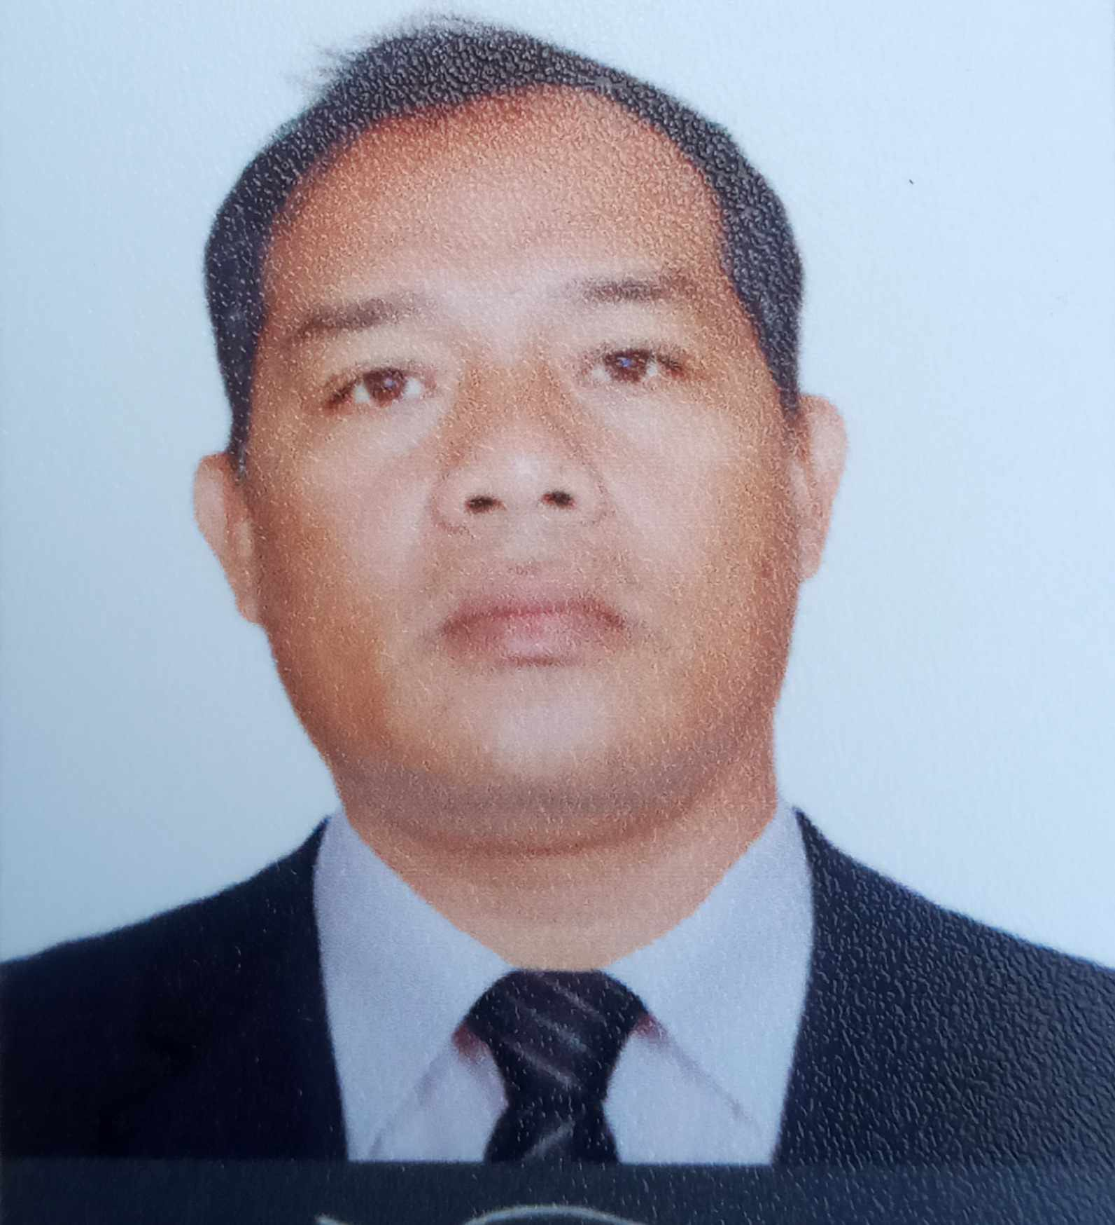**MICHAEL O. ORTEGA**

Email Address: michaelortega1378@gmail.com

Phil. Mobile Number +639454401133

Passport NumberP725836A

**Position Desired**: **Truck Driver/ Bus Driver**

**OBJECTIVE**

To impart my knowledge and skills for the benefit of my company and myself

and work up to standards and to become a competent and productive

employee.

**WORK EXPERIENCE:**

February 06, 2017 **Truck Driver/Bus Driver**

August 30, 2022 M.H. Alshaya Co. W.L.L.

Doha Qatar

* Ensuring the safety and security of the load during transportation
* Ensuring all documentation connected to the load is fully completed and in compliance with company standards
* Assisting in the safe loading and unloading of goods
* Ensuring the highest level of customer service at all times when dealing with company employees and external customers.
* Complete daily checklist of vehicle condition
* Operate a bus safely and efficiently to transport passengers to various destinations
* Adhere to all traffic laws and regulations while driving
* Inspect the bus before and after each trip to ensure it is in good working condition
* Maintain a clean and orderly bus interior
* Communicate with dispatch and other drivers as needed to coordinate routes and schedules
* Report any accidents, incidents, or mechanical problems to the appropriate authorities

November 2, 2012 to **Valet Driver/Bus Driver**

August 30, 2016 Abraj Qatar Group

Doha, Qatar

**Worked Performed:**

* Understand and meet all customers need quickly, professionally and accurately
* Parked and retrieves customers vehicle in a timely fashion
* Responsible for ensuring work conducted in a safe manner by maintaining traffic safety laws
* Complete a circle check for each vehicle and notes any pre-existing damage of a vehicle
* Maintain open line communication with my supervisor
* Pick and drop staff from accommodation to workplace and vice versa
* Check and monitor vehicle condition daily

December 13, 2010 to Valet Attendant**/Bus driver**

September 30,2012 Tanzifco Company

Doha, Qatar

**Worked Performed:**

* Understand and meet all customers need quickly, professionally and accurately
* Parked and retrieves customers vehicle in a timely fashion
* Responsible for ensuring work conducted in a safe manner by maintaining traffic safety laws
* Complete a circle check for each vehicle and notes any pre-existing damage of a vehicle
* Maintain open line communication with my supervisor
* Pick and drop staff from accommodation to workplace and vice versa
* Check and monitor vehicle condition daily

April 2001 – January 2007 **Company Driver**

Citi Appliance

Mansalay Oriental Mindoro, Philippines

**Worked Performed:**

* Drive safely to their destination
* Help loading and unloading of products
* Keep logs of the activities and make sure their vehicles are maintained good working order.
* Pick and drop company staff.
* Package delivery service drivers.
* Accept payment for services and handle other paper related to the delivery

**Educational Attainment:**

College Bachelor in Agricultural Technology

Romblon State College 2000

Training Health and Safety Environment Officer

2007

SMAW NCII (Shielded Metal Arc Welding)

2008

**Personal Data:**

Birthday: April 13, 1978

Status: Married

Father’s Name: Zacarias Ortega

Mother’s Name: Lolita Ortega