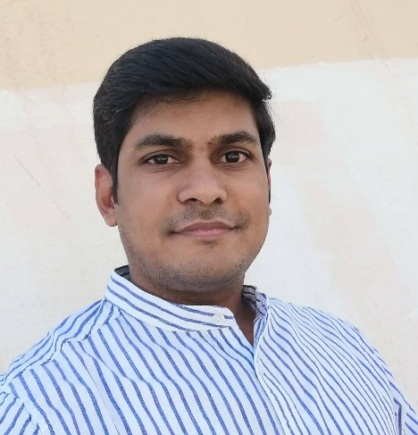***MOHAMMAD SARIK ALI***

***DOHA, QATAR***

***CONTACT- +974-59982431*** [***Coolcoolraj786@gmail.com***](mailto:Coolcoolraj786@gmail.com)

**JOB OBJECTIVE**

To explore my potential to the fullest by working with on organisation rendering competitive environment with avenues for professional growth and remuneration com measure with my abilities & operational skills.

**WORK EXPERIENCE**

* **DAILY CASH COLLECTOR**

SAHARA INDIA NON-BANKING PVT LTD.

Jan 2008 – Mar 2011, Hajipur, Bihar, India.

* + Handled high volume of cash transactions with accuracy and efficiency.
  + Utilized POS system to process cash and credit card payments.
  + Managed daily cash transactions for a busy retail store.
* **CASHIER**

APR 2011-MAR 2013, RIYADH, SAUDI ARABIA

FAST DELIVERY COMPANY

* Managed cash transaction with accuracy and efficiency in a fast-paced retail environment.
* Operated POS system and processed payments using various payment methods.
* Assisted with inventory management and restocking merchandise to meet customer demand.
* Handled customer inquiries and requests with professionalism and courtesy.
* **JUNIOR ACCOUNTANT**

MENA PAINTS FACTORY. RIYADH, SAUDI ARABIA

APR 2013 – JUNE 2015

* Processed and reconciled account payable and account receivable.
* Prepare financial statements and reports for management review.
* Maintained accurate and up-to-date financial records.
* Assisted with budgeting and forecasting activities.
* **FLEET MANAGER**

AARIF CABS PVT LTD, DELHI, INDIA

Aug 2015 – Oct 2017

* Managed inventory.
* Responds to emergencies and breakdowns to ensure minimal disruption to operations.
* Maintained accurate records of mileage, fuel consumption and maintenance activities.
* **ACCOUNTS PAYABLE SPECIALIST**

LAFACOM CONTRACTING COMPANY, RIYADH, SAUDI ARABIA.

NOV 2017 – DEC 2020.

* Developed and implemented efficient payment processing procedures to streamline operations and optimize cash flow.
* Performed monthly reconciliation of accounts payable accounts ensuring accuracy and compliance with company policies and procedures.
* Collaborated with internal departments to review and validate invoices, purchase orders and payments term, ensuring proper authorization and documentation.
* **SALES ASSOCIATE, VODAFONE**

DOHA, QATAR, JULY 2022- DEC 2022

* Provided exceptional customer service while processing payments and resolving billing inquiries.
* Complete activation connection of Fiber, data & calling card.
* **FREELANCER**

ZAROQ LIMOUSINE. DOHA, QATAR

* Work as a freelancer
* Work with a ride-hilling service Uber & Careem.
* **PROFESSIONAL CREDENTIALS**.
* H.S.C. Passed On 2nd Div. (B.I.E.C. Patna) 2006

10+2 (intermediate).

* DIPLOMA IN COMPUTER APPLICATION WITH ACCOUNTING. 2008
* SAP Operating.

(SANT KABIR COMPUTER EDUCATION CENTRE), HAJIPUR, VAISHALI, BIHAR.

* **PERSONAL PROFILE**

Father Name: Late Asgar Ali

Date Of Birth: 15 Jan. 1990

Marital Status: Married

**Linguistic Proficiency: Arabic, English, Urdu & Hindi**.

Nationality: Indian

* **Driving License: Qatar, Saudi Arabia, India.**

**WHAT I BRING TO THE ORGANISATION.**

My enthusiasm, willingness to learn, innovative ideas, working skills and the experience of interacting with various kinds of clients. I can take on any challenges given to me, working well as a Team man as well as at an individual level.

(Mohammad Sarik Ali)