**SAHI GOPAKUMAR KUMAR DRIVER & MESSENGER**

Jul 2022 – Present

**DELIVERY AGENT CUM MESSENGER**

**IBN AL HAYTHAM MEDICAL CO. DOHA, QATAR**

July 2017 – Jan 2022

**ASSISTANT SECURITY SUPERVISOR**

**G4S QATAR WLL**

Mar 2015 – Apr 2017

**LIMOUSINE DRIVER**

**DOHA LIMOUSINES, QATAR**

Nov 2013 – Dec 2014

**FORKLIFT OPERATOR**

**J.M BAXI & CO. CHENNAI, INDIA**

**Duties & Responsibilities**

* Safely operate company vehicles to transport personnel, packages, and goods to designated locations.
* Adhere to all traffic laws, regulations, and company policies while driving.
* Ensure timely and efficient transportation of employees, clients, and goods.
* Plan and follow the most efficient routes for deliveries and pickups.
* Conduct regular vehicle inspections and maintenance checks.
* Report any mechanical issues or malfunctions to the maintenance team and ensure timely repairs.
* Follow all safety protocols and procedures to minimize risks.
* Ensure that the vehicle is equipped with necessary safety gear, such as seat belts, first aid kits, and fire extinguishers.
* Maintain accurate records of driving hours, mileage, fuel consumption, and any incidents or accidents.
* Complete and manage all necessary paperwork related to transportation duties.
* Collect and deliver documents, packages, and other items to various locations, ensuring timely and accurate delivery.
* Obtain signatures or proof of delivery when required.
* Collect and sort incoming mail and packages for distribution within the organization.
* Prepare and dispatch outgoing mail and packages.

**VEHICLE OPERATION**

**WORK EXPERIENCE**

**S K I L L S**

**Qatar**

[**sahigkumar7@gmail.com**](mailto:sahigkumar7@gmail.com)

**+974 31225417, +91 9947751842**







**CONTACT**

**P R O F I L E**

Dedicated and reliable professional with extensive experience as a Driver and Messenger, seeking a position in a dynamic organization where I can utilize my skills in safe and efficient driving, timely deliveries, and effective communication. Committed to maintaining the highest standards of safety, punctuality, and confidentiality while providing exceptional support in transporting people, documents, and goods. Eager to contribute to the success of the team through diligent work ethic and strong organizational abilities.

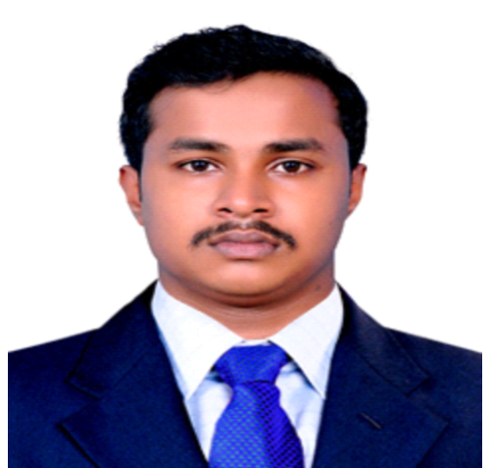

**INTERPERSONAL SKILLS**

**TIME MANAGEMENT**

**PROFESSIONALISM**

**ERRAND RUNNING**

**TIME MANAGEMENT**

**CUSTOMER SERVICE**

**MAIL HANDLING**

**PACKAGE DELIVERY**

**DOCUMENTATION**

**Detail-Oriented**

**SAFETY AND COMPLIANCE**

**VEHICLE MAINTENANCE**

**TRANSPORTATION**

**CONFIDENTIALITY**

**COMMUNICATION**

**LEADERSHIP SKILLS**

* Perform various errands as requested by company personnel, including purchasing supplies, making bank deposits, and other administrative tasks.
* Maintain accurate records of deliveries, pickups, and other messenger activities.
* Ensure that all delivered items are documented and accounted for.
* Interact professionally with clients, customers, and colleagues while performing duties.
* Address any concerns or issues promptly and courteously.
* Manage time effectively to balance driving and messenger duties.
* Prioritize tasks to ensure timely completion of all responsibilities.
* Maintain clear and effective communication with supervisors, colleagues, and clients.
* Report any delays, issues, or changes in schedule promptly.
* Handle sensitive documents and packages with discretion and maintain confidentiality.
* Ensure that all information and items are delivered securely.
* Present a professional appearance and demeanor at all times.

**PERSONAL INFO**

**Nationality : Indian**

**DOB : 17/10/1992**

**Marital Status : Married**

**Gender : Male**

**Passport No : V4440415**

**Qatar Id : 29235606546**

**DECLARATION**

I hereby declare that the above-mentioned information is correct to the best of my knowledge and belief.

**SAHI GOPAKUMAR KUMAR**

* **HEAVY EQUIPMENT’S CERTIFICATES**

**SREE KRISHNA INSTITUTES OF HEAVY EQUIPMENT’S**

KERALA, INDIA

| 2013

* **ITI DIESEL MECHANIC**

KERALA, INDIA

| 2013

**CERTIFICATIONS**

**English**

**Hindi**

**Malayalam**

**Tamil**

**Arabic**

**LANGUAGES KNOWN**

**Valid Indian LMV Licence**

**Valid Licence EXVTR, CRANE, FORKLIFT**

**Valid Qatar Licence : 29235606546**

**Date of Expiry : 27/01/2029**

**LICENCE DETAILS**

**EDUCATIONAL QUALIFICATIONS**

* **HIGHER SECONDARY EXAMINATION**

**BOARD OF HIGHER SECONDARY EXAMINATION**

KERALA, INDIA

| 2011

* **SECONDARY EXAMINATION**

**BOARD OF PUBLIC EXAMINATION**

KERALA, INDIA

| 2009