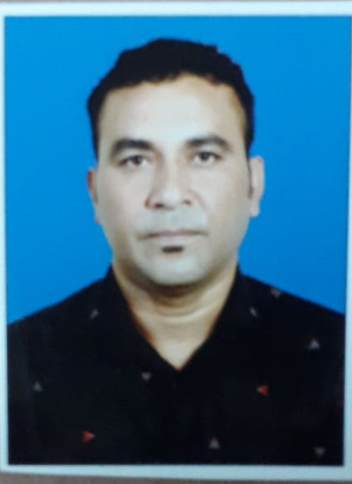 |  | BASHEER T.M
Profile  I am a well-organized person with basic ethics, focused on delivering quality service wherever I am employed. I am on the lookout for a suitable placement that offers scope for optimum utilization of my knowledge backed by vast experience.  Contact  PHONE:  974-66508970  EMAIL:  mkmbasheer31@gmail.com |  | WORK EXPERIENCE  - 5 years working experience as driver in Qatar  - 2 years working experience in as a van salesman in ksa  - 2 years working experience as Van salesman in U.A.E.  EDUCATIONAL QUALIFICATION  High School  TECHNICAL QUALIFICATION  - MS Office  capabilities  - Ability to discharge diverse responsibilities independently  - Good telephone manners and communication in English  - Adept in MS Word, Excel & Outlook  - Positive approach and team player

PERSONAL DETAILS
Date of Birth : 10 May 1970
Sex : Male
Marital status : Married
Driving License : Valid Qatar Driving
Languages Known : English, Arabic, Hindi and Malayalam

Declaration
I hereby declare that the above details are true as of my knowledge.

