**Position Desired: Electrician**

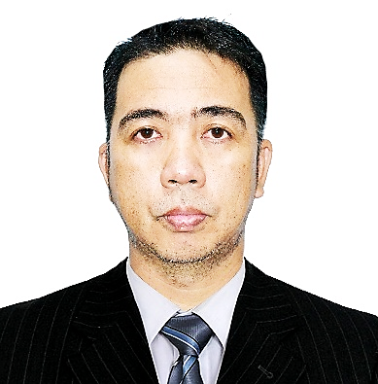

**NESTOR PERFECTO ALOLOD**

Building No. 166, Street 49, Zone 57, Industrial Area

Doha, Qatar

 +97471165864

Email Address: alolodn96@yahoo.com

**Skills:**

* Good communication skills
* Abilities to monitor and work under pressure; able to provide flexible and efficient services
* Excellent mathematical and statistical skills to ensure full conformance with client's specifications, and offer proper judgment
* Strong analytical skills and critical thinking abilitie

**Professional Experience**

**• Electrical Maintenance Technician**

**Rumaillah Facilities Management**

Doha, Qatar

June 15, 2022

Present

**Job description**

* Perform preventive maintenance on all building

and critical system equipment.

* Perform a wide variety of function such as installation, maintenance

and repair of equipment for generating distributing and utilizing electrical energy.

* Maintaining all electrical components of the facility as well

as general maintenance on all equipment of the facility.

* Maintaining the everyday function of the building facility.
* Maintaining and troubleshooting of electrical and electronic problem.
* Use instrument to test circuits and replace or install new

power, lights, electronics and control circuits

**• Maintenance Facility Cleaner**

**Romago Cleaning Services**

Boni Avenue, Metro Manila

October,24,2018

May 30,2022

**Job description**

* Frequent cleaning and disinfection high touch area.
* All building offices dusting, vacuuming and sweeping.
* All building, toilets, pantry mopping and stepping.
* Floor mopping, sweeping and supply all maintenance task.
* Dust and polish various surfaces.
* Vacuuming carpet floor.
* Cleaning agent
* Empty trash bin
* Clean bathroom and public areas
* Rest room maintenance
* Sanitization and disinfection
* Stock and maintain supply
* cleaning mirror and glass sliding door
* cleaning and sanitizing fixtures

**In-house Trainings & Seminars:**

Manual handling

Pre-job and Ptw

awareness

Working at heights

Hot works

Confined space

Heat stress awareness

Electrical and lotto awareness

**Educational Background:**

**College:**

Marine Electro-Electrical Technology (1994-1996)

Mariners polytechnic college

Panganiban drive naga city, Philippines

**Secondary:**

Milaor national high school

(1988-1992)

San Jose Milaor camarines sur

**Primary:**

Minalabac central school

(1982-1988)

. Minalabac camarines sur

**Personal information:**

Date of birth: August 01,1975

Place of birth: San Juan Street, Minalabac Cam Sur

Nationality: Filipino

Height: 176cm

Weight: 70kg

Civil status: Married

Religion: Roman catholic

Permanent address:203 Paso street Bagumbayan Taguig City, Metro manila

**Flexibility:**

Willing to work in flexible shifts, anywhere in the States. Quick and adaptable to the environmental requirements, capable of handling independent responsibilities.

**Declaration:**

I hereby declare that the above-mentioned information is correct and true as per my knowledge.

**Nestor Perfecto Alolod**

Applicant’s Signature