AZHAR AHMED.T.K 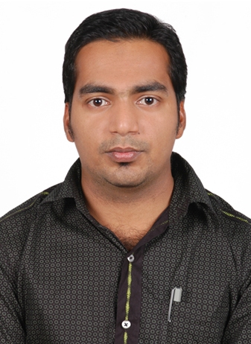
Email : azharahmed007@gmail.com

Mobile : +974-31524011

Objective:

To secure a career in a growth oriented organization, which appreciates hard work and richly rewards it. Also specific interest in making a significant contribution to the success of my employer and where various experience can be utilized and get opportunity to learn more.

AutoCAD Draughtsman with 15 Years’ Experience
(Specialized in Civil, Architectural, Fit Out Shop Drawings)

Strengths:

- Energetic, dynamic & sincere person with outstanding skills.
- Ability to work as a team member & contribute to design lay-out preparation.
- Capable at working in a high-pressure working environment and meet tight deadlines.
- Ability to establish to new situations and learn new assignments.
- Computer literacy in MS Office, AutoCAD (all versions) 2D.

Technical Education:

- Diploma in Civil engineering draftsman from The Kerala Technical Institute (Affiliated to I.T.E.S Mumbai, Govt. Of India Regd.)
- AutoCAD with civil draftsman
(CAD group, Kerala, India)
- Diploma in computer hardware and network engineering (MCSE)
(UNIQUE SOLUTION, Kerala, India)

Academic Qualification:

- Higher Secondary (From the board of public examination.
- Secondary School Leaving Certificate (From the Board of Public Examination)

Professional Experience Summary:

Company: IKA Construction.WLL Doha, Qatar
(From March. 2020 To Present)

Projects:
- DOHA OASIS STAFF RESIDENT. Doha, Qatar.
- DESIGN AND BUILD FOR CONSTRUCTION OF PANDA ENCLOSURE & TOURISTIC VIEWING FACILITY AT AL KHOR ZOO. Doha, Qatar.
- UPGRADE OF LUSAIL CIRCUIT BUILDING & INFRASTRUCTURE(LCSC).

Position - Senior Draughtsman (Fit Out, Architectural )

Company: PROFESSIONAL BUILDERS TRADING & CONTRACTING.
Doha, Qatar ( From April. 2016 To March.2020)

Projects:
- PROPOSED 3B+G+M+43 Hotel & Serviced Apartment BLDG. (WALDORF ASTORIA) Doha, Qatar.
- AL BAYT STADIUM – AL-KHOR CITY. Doha, Qatar.
- AL THUMAMA STADIUM AND PRECINCT. Doha, Qatar.

Position - Senior Draughtsman (Fit Out, Architectural )

Company:  BELHASA SIX CONSTRUCT
(From March 2009 To September 2015)

Projects:
- YAS MALL Yas Island, Abu Dhabi. U.A.E
- New Doha International Airport (NDIA) Doha, Qatar
- Doha Convention Centre & Tower. Doha, Qatar

Position - Auto CAD Draughtsman (Civil, Architectural)

Company Profile: Belhasa Six Construct (Besix) (www.besixgroup.com) is one of the leading contractors in U.A.E, Bahrain, Qatar, Oman & Saudi Arabia engaged in Construction of Bridges, Quay Walls, Roads and Bridges including all other Services, Sewerage and Drainage works, High Rise buildings and other Infrastructure development works including Water Treatment Plant, Power Plant and Sewerage Treatment Plant etc.

Company: AL-HANI CONSTRUCTION &TRADING CO. HAWALLY, KUWAIT
(From May 2006 to Feb 2009)
Projects:
- Kuwait National Library (Ministry of public work)

Position - Auto CAD Draughtsman (Civil, Architectural)

Company: CAD Group. Kerala, India.(From 2003 to 2006)

Position - Auto CAD Draughtsman.

Job Profile:
- Specialized in Coordination setting outs.
- Experienced in Civil, Architectural & Fit Out Drawings
- Experienced in plotting drawings in various plotters.
- Produced preliminary drawing and construction plans including Commercial, Residential Development and Apartment complexes.
- Draw all the Architectural & Structural Drawings through AutoCAD and submit for Municipality Sanction.
- Supervised construction project involving work flow, modification and quality control.
- Conduct site measurement & site inspection.
- Conceptualize space planning & design office furniture requirements in AutoCAD program. Presenting isometric, technical, shop drawings & spot perspectives to clients. Organize & direct schedules of delivery & installation.

Personal Information:

Name :AZHAR AHMED.T.K
Nationality :Indian
Passport No. :L3834488
Date of issue :15-07-2023
Date of expiry :14-07-2033
Sex : Male
Religion :Muslim
Marital status :Married
Visa status :Employment visa
Date of Birth :27-02-1984
Languages Known :English, Malayalam, Hindi, Tamil,
Contact No. : +974-31524011 [Mobile]

The above information is correct to the best of my knowledge and belief.

AZHARAHMED T.K
Qatar, Doha

