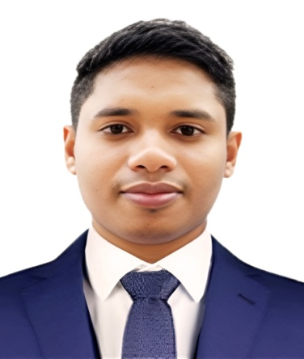

RESUME OF

**TAZUL ISLAM**

**Mobile No: +974 50302511**

**E-mail: tajul7737**[**@gmail.com**](mailto:swathimahendhar223@gmail.com)

**CAREER OBJECTIVE:**

I am an identity person in the organization with improve my knowledge innovative skills. Hard worker and Good leadership in the organization, Adjustable with any environment.

**Carrier Profile:**

* Young, energetic, hard working and quick learner.
* Capable to face exacerbate situation.
* Positive towards duties and responsibility.
* Extrovert mentality.
* Ability to work in unison.

**EDUCATIONL QUALIFICATION:**

| **Qualification** | **Institute Name & Place** | **Board** | **Passing Year** |
| --- | --- | --- | --- |
| **H.S.C** | Chalan Collage, comilla | Board Of Comilla | 2015 |
| **S.S.C** | Charijania Dhakhil Madrasah, comilla | Board Of Dhaka | 2012 |

* **TECHNICAL EDUCATION**
* Goverment Department Refrigeration and Air Conditioning,Centrecomilla.
* Graphic Designer Feni computer Institute**.**
* I have a Driving licenses in Qatar manual licenses.

**HOBBIES:**

* chess games
* Reading News Paper

### Duties & Responsibilities :

* *My responsibilities include the service, repair, maintenance, and installation of Air conditioning systems:*
* *Carrying out repairs and replacing damaged parts.*
* *Installation of new compressors, condenser coils, evaporator coils if failure comes, than leak test, vacuum the system and charge Freon.*
* *Install or repair electrical connections.*
* *Chilled water system,primary secondary pump etc.*
* *Tagging the damage parts for Inventory purpose.*
* *Repairs and replacement of condenser fan motors and blades,Evaporator Blowers.*
* *Working AHU,FCU,sprit types ac,windor ac,pakeg unit,VFD,VRV,etc.*
* *BMS operator syetem*
* *Carrying out inspections of completed repairs to ensure that the A/C System working fine.*
* *qualified to install, operate, maintain, troubleshoot and repair heating, ventilation, air conditioning and refrigeration (HVAC)*

*systems,technical manuals and diagrams.*

* *Bye Equipment knowledge*
* *HVAC good knowledge.*
* *Electrical knowledge*
* *Replace lights,switch,beaker etc.*
* *Following a checklist to ensure that all key work has been done***.**

**QID & VISA DETAILS**:

QID:29405020106

QID Ex days 30/10/2024

**EXPERIENCE** :

* 3 years experience as *R/AC* in Bangladesh
* 5 years experience as HVAC Tceh. MMS company in Qatar Continues
* 1 years experience HVAC in JW marweb Tower Qatar.

**Languages Known:**

Bengali, English & Hindi

**PERSONAL DETAILS**

Date of birth : 08/07/1994

Gender : Male

Marital Status : Married

Passport : EG 0621950

Nationality : Bangladesh (by birth)

**Declaration:**

I certify that all information stated in this resume is true and complete to the best of my knowledge. I authorize my potential employers to verify the information provided in this resume.

Signature

Date:……………………….  **( TAZUL ISLAM )**