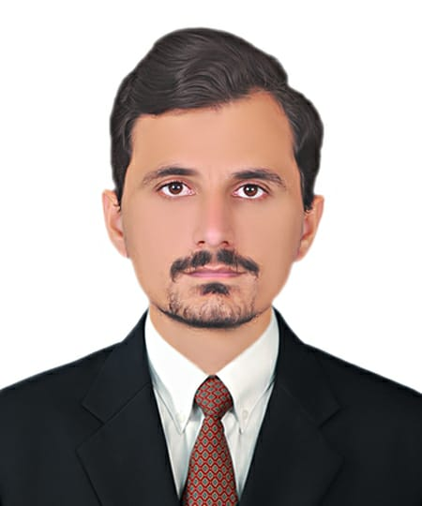

HUSSNAIN NAWAZ

Electrician

# EDUCATIONAL QUALIFICATIONS

**Matriculation**

Board of intermediate & secondary education, Gujranwala, Pakistan

# TECHNICAL QUALIFICATIONS

One Year Diploma in Electrical from Fauji Foundation in 2018.

**HUSSNAIN NAWAZ**

**CONTACT**

**ADDRESS**

Mohala Mango Peer, Post Office Tanda, District Gujrat

**Email Address**

[hussnainnawaz153@gmail.com](mailto:ashfaqsipraa@gmail.com)

**Phone**

+923450825091

**PERSONAL DETAILS**

**CNIC NO.**

34201-8695442-3

**Date of Birth**

23rd July 1996

**Passport No**

CY9614422

**LANGUAGES**

* Urdu
* English
* Punjabi

# SKILLS

# Electrical Installation and Maintenance

# Troubleshooting and Problem-Solving

# Skilled in diagnosing electrical issues and implementing effective Solutions

# Blueprint Reading and Interpretation

# Safety Compliance

# Technical Proficiency

# Customer Services

# WORKING EXPERIENCE

1. **From 23rd December 2022** to **5th March 2024**

* I have 2 years working experience in Wayat Shine Maintenance and Cleaning Company, Qatar

1. **From 8TH April 2018** to **10th November 2021**

* I have 3 years working experience as an Electrician in The Handyman Electrical Services in Islamabad Pakistan.

# DECLARATION

I hereby declare that the information given above is true and accurate to the best of my Knowledge.

Date:29th July, 2024 Signature

HUSSNAIN NAWAZ