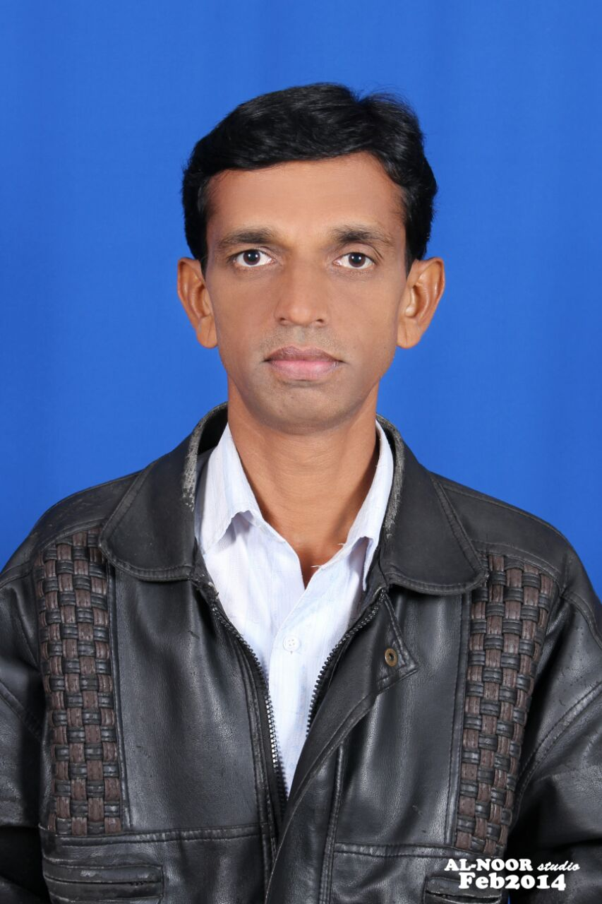

CURRICULUM VITAE

MOHD. ASIF IQBAL
DOHA QATAR

Cell No : +974 50685967 email : mdasif.iqbal2468@gmail.com

OBJECTIVE

To obtain a high-level, challenging, permanent position that allows me to utilize my expertise and to secure the networks in an environment conductive to continual advancement of knowledge and skills, capable to confront any kind of situations and problems using my driving experience as a tool.

POSITION DESIRED

I am currently seeking a position of DRIVER

WORK EXPERIENCE :

I have worked as an House Driver in Doha Qater for Past 15 years.

EDUCATIONAL QUALIFICATION :

- 10+2 from Andhra Pradesh.

- Diploma in Electronics and Communication Engineering from Gulbargah

- C,C++,J2SE,J2EE/Advance Java from NIIT.

- Hardware & Networking from APTECH.

- Higher in Typewriting.

PERSONAL DETAILS :

Name : Mohammed Asif Iqbal.
Father’s Name : Mohd. Azher Hussain.
Date of Birth : 16/07/1971
Passport No. : Y1062770
Expiry Date : 30/03/2034
Religion : Islam.
Native Place : Hyderabad.
Nationality : Indian.
Language Known : English/Urdu/Hindi.
Hobbies : Games & Music.
Parmanent
Address : H.No. 9-10-42.
Attara Seedi, Resham Bagh,
Golconda Fort,
Hyderabad 500008
I N D I A

e-mail. : mdasif.iqbal2468@gmail.com

In View of the above, I request you to be kind enough to give an opportunity to serve you esteemed organization in the capacity mentioned above, for which act kindness, I shall be very thankful and grateful to you.

Thanking you Sir,

Place : DOHA
Date : 28/10/2024 Yours faithfully,

