- 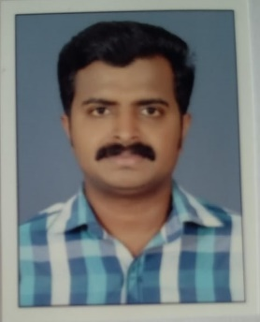  Name: SANOOP KUMAR S  Mob: +974 30595647  Email: sanoopthakku100@gmail.com  Address:  Karikkathil Veedu,  Thudayannur (P.O),  Kadakkal, Kollam (Dist.),  Kerala, India.  Pin: 691536. | Career Objective  Seek the challenging and exciting position of Welder with a firm where my huge knowledge and experience will be fully utilized to produce top quality jobs.  A Welder with strong background in using welding equipment; making metal articles and repairing Metal parts of machines and equipment.  Educational Background  - Indian Institute of Welding Technology on April 2006.  (Government of Kerala)  - Board of Higher Secondary Examinations (HSE) on March 2004.  (Government of Kerala)  Professional Summary  - Qatar – 2015 Dec’ – Till Date  Designation: WELDING SUPERVISOR/FOREMAN  (ENERTEC, QATAR)  (Worked as a Welding Supervisor/Foreman)  - Qatar – 2012 – Nov’ 2015  Designation: WELDER  (RAVELAAN ELECTROMECHANICAL LLC, QATAR)  (Worked At Qatar Petroleum NGL 1, 2, 3 & 4 Natural Gas Plant (NGL),  Messaeed for the Non-Sensitive Shutdown (NSSD) maintenance work  for 3 years. QP approved Welder.).  - India - 2006-2007, 2009-2012  Designation: WELDER  (RAJI ENGINEERING, THUDAYANNOOR (PO), KOLLAM (DIST.), KERALA).  - Dubai - (2007-2009)  Designation: WELDER  (YONGNAM ENGINEERING & CONSTRUCTION PVT LTD).  Skills & Software Knowledge  - MS Office  - Excellent communication skills  - Good ability to work in team  - Good interpersonal skill  - Inquisitive for learning  - Devotion and dedication to work  Key Projects  - Industrial Warehouse  - Shopping Malls  - Gas Plants  Passport Details  Passport No. : W 3751472  Issue Date : 15-09-2022  Expiry Date : 14-09-2032  Place Of Issue : Doha, Qatar  Driving License Details  License No. : 28635643852  Issue Date : 10-01-2018  Expiry Date : 14-05-2028  Place Of Issue : Doha, Qatar  Personal Data  Date of Birth : 05-May-1986  Gender : Male  Father’s Name : Sasidharan  Nationality : Indian  Marital Status : Married  Skype ID : sanoopthakku100  Languages Known : Malayalam, Hindi, English & Tamil  Hobbies : Listening Music, Travelling & Reading  Declaration  I Sanoop Kumar S hereby declare that all the information provided above is true to the best of my knowledge.  Place: Yours Faithfully  Date: SANOOP KUMAR S

