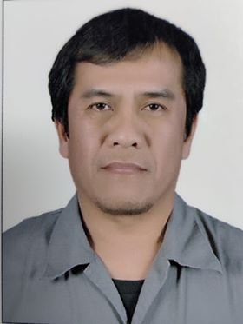
ALDRIN C. SILVA
Contact #: +966578526270
Email: aldrinsilva46@gmail.com
Birthday: August 23, 1970

DESIRED POSITION: DIESEL MECHANIC

PERSONAL STATEMENT:

Dedicated and responsible Diesel Mechanic with more than 10 years’ experience in engine repair and maintenance.
To use my skills in the best possible way for achieving the company’s goals.

TECHNICAL SKILLS:

- Responsible and dedicated
- Organized and detail-oriented
- Good communication skills
- Flexible
- Quick learner

WORK EXPERIENCES:

NAME OF COMPANY : (2P) PERFECT PRESENTATION COMPANY
Address : Riyadh, Kingdom of Saudi Arabia
Date : July 01, 2021 - Present
Position : Diesel Mechanic

NAME OF COMPANY : HOUSSAM CONTRACTING COMPANY (HCC)
Address : Riyadh, Kingdom of Saudi Arabia
Date : December, 2017- June, 2021
Position : Diesel Mechanic

NAME OF COMPANY : HOUSSAM CONTRACTING COMPANY (HCC)
Address : Southern Border Kingdom of Saudi Arabia
Date : October, 2015- December, 2017
Position : Diesel Mechanic

NAME OF COMPANY : ZAMIL OFFSHORE SERVICES CO. LTD.
Address : Kingdom of Saudi Arabia
Date : June 18, 2012 – June 18, 2015
Position : Diesel Mechanic

NAME OF COMPANY : HADI HAMAD AL- HAMMAM EST.
Address : Prince Naif St.
P.O Box Rahima 31941,
Kingdom of Saudi Arabia
Date : March, 2011- February, 2012
Position : Oiler/ Mechanic

NAME OF COMPANY : HADI HAMAD AL-HAMMAM EST.
Address : Prince Naif St.
P.O Box Rahima 31941,
Kingdom of Saudi Arabia
Date : March, 2010- October, 2010
Position : Oiler/ Mechanic

NAME OF COMPANY : MOHAMMAD AL-MOJIL GROUP
Address : Dammam, Kingdom of Saudi Arabia
Date : October, 1998- July, 2009
Position : Marine Diesel Mechanic

I hereby certify that all information are true and correct to the best of my knowledge and belief.

ALDRIN C. SILVA
Applicant

