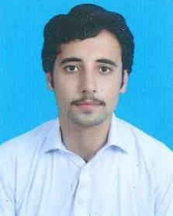**CURRICULUM VITAE**

# ABDULLAH QIMAT KHAN

## Mob: +974-30926089

[**Email:abdullahrahamdil@gmail.com**](mailto:abdullahrahamdil@gmail.com) **DOHA-QATAR**

**OBJECTIVES**

Looking for a challenging position in a reputable establishment where I can apply my Experience, knowledge and skills, and where I can a successful role.

**PERSONAL DETAILS**

* Name : **ABDULLAH QIMAT KHAN**
* Date of Birth : **20/08/2003**
* Sex : **Male**
* Religion : **Islam**
* Nationality : **Pakistan**
* Marital Status : **Married**
* QID : **30358603805**
* Expiry : 18/10/2023

**ACADEMIC QUALIFICATION**

* Successfully completed **Higher Secondary Certificate** in **Medical Science** (12th) from

- Pakistan.

**PROFESSIONAL EXPERIENCE**

* **LTV Driving License Qatar**
* **2 year work experience as supervisor in Pakistan**
* **5 month working experience as Lawn growers and landscape in Green Qatar Enterprise**
* **4 months work experience as Team leader of Plumbers in construct & trading**

**Languages Known**

## English, Arabic, Urdu & Pashto.

**Passport Details**

* Passport No : **MY1075371**
* Passport Expiry : **12/01/2027**

**PERSONAL SKILLS**

* Good Communication skill.
* Flexibility in terms of working hours.
* Energetic, highly motivated to win.
* Hard working to handle the pressure and shift duty with pleasure in every field.

**DECLARATION**

I hereby declare that the above information is true to the best of my knowledge and belief.

# ABDULLAH QIMAT KHAN