TEYAN AMINAKE VINCE

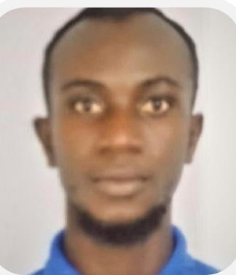

**Driver( manual licenses)**

## CONTACT

+974 66072082

[aminakevince@gmail.com](mailto:aminakevince@gmail.com) DOHA – QATAR, DOHA

[www.linkedin.com/in/aminake-vince](http://www.linkedin.com/in/aminake-vince)

## LANGUAGE

**French English**

## SKILL

* Biogas production
* Solar installations
* Driving
* Heavy duty operator
* Firefighting safety
* Problem solver
* Pipe fitting

## HOBBY

* Football
* Travel
* Voluntary service

**Driver’s license***:*

light vehicles: manual drive

## PROFILE

To utilize my technical skills to provide a professional service to this organization by applying my full knowledge and understanding for the betterment of the organization.

## PROFESSIONAL EXPERIENCES

**Head of operations**

***Marion Paint and Services (MPS) Quarry*** Douala | 2021-2024

-Production supervisor

-General maintenance of equipment

-Purchase of equipment

-Storage management

* Weighbridge operator
* Work safety
* Finances collector

**Voluntary services at SO.SA.RA as unit operator**

# TRAININGS

1. 15/03/2024 : **ALISON**

**-**ISO 45001:2018 - Principles of Occupational Health and

Safety Management Systems

1. 19/11/2018-19/12/2018***: GEOSAVERS INTERNATIONAL***

-Practical training in advanced GIS applied to earth

-Training on well log analysis

1. 20/11/2017 - 30/11/2017***: SHILO SAFETY GROUP***

-Training on basic on fire safety with practice

1. 01/04/2017 - 31/06/2017***: GREEN ENERGY AFRICA***

-Biogas installation and solar panel installations

# EDUCATION

**BACHELOR OF TECHNOLOGY IN CHEMICAL ENGINEERING (**IUC20E0061319)UNIVERSITY OF BUEA

Institut universitaire de cote (IUC) ***Douala*** 2020 - 2021

**HND IN PETROCHEMICAL ENGINEERING, (19PCH0002) 12.71 AVERAGES**

Golf field university institute of petroleum ***Limbe*** 05/09/2017-02/08/2019

**GENERAL CERTIFICATE OF EDUCATION EXAMINATION, ADVANCED LEVEL** (Cand.No 116577008)

Government secondary school ***Bonadikombo Limbe*** JUNE 2016