**SAJID MUHAMMAD** 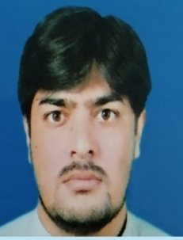

**Languages Known : English, Hindi, Arabic**

**Marital Status : Married**

**Mobile : +974 70296165(Qatar)**

**E-Mail : msajidm315@gmail.com**

**Education : Graduate (Bachelor Of arts in 2007)**

**Nationality : Pakistan**

**Visa Status : Work Visa With NOC and Driving License in Doha Qatar.**

**Assignments in Sales & Marketing, Customer Relationship**

# Work Experience

**18 years driving experience**

**Company.. Al meera (Qatar)**

**Designation. Fruit & Vegetables supervisor**

**Duration. May 2022 until now**

**Job responsibilities.**

* **Daily checking hygiene of staff**
* **Check daily price and put new updated price**
* **Check display area and maintain quality**
* **Daily ordering for new item and proper quantity.**

**Company : Yallow Taxi ( Qatar )**

**Designation : Driver**

**Duration : Sep 2016 to Mar 2018**

**Company : Global limousine (Qatar)**

**Designation : Driver**

**Duration : Apral2018 – May 2020**

**Company: Al Tajwal Limousine ( Qatar)**

**Designation: Driver**

**Duration: jun 2020 – Jan 2022**

**Company. Arabia Taxi (Dubai)**

**Designation. Driver**

**Duration.. 2008 to 2010**

**Company.. AL Minral water(Abu Dhabi)**

**Designation. Van salesman**

**Duration. 2010. - 2013**

**Company. Souq.com(Dubai)**

**Designation. Van Delivery Driver**

**Duration. 2013. - 2015**

**Date SAJID MUHAMMAD**