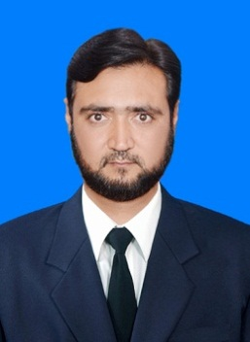

**F A R H A D – A L I**

***Postal Address***

*Bilal colony near HIT gate no 5 house 100/2 Taxila Cantt*

*Tehsil Taxila District Rawalpindi*

*Mohalla Ayub Khel, Village & Post Office Zaida, District & Tehsil Swabi,*

*Cell:* ***+92-315-5131606***

*Email:* [autocad.and.blender.designer@gmail.com](mailto:autocad.and.blender.designer@gmail.com) or farhada80@gmail.com

## **Objective**

*To enhance and develop the ability of working in a competitive environment where I could have the opportunity to work enthusiastically for the attainment of organization goals and objectives as regards OSH.*

## **EXPERIENCE**

* **AutoCAD Operator** **in** Mimar Consultants SWABI Branch from **2005** to Jul **2009 (2D & 3D Civil work feet in inches experts)**
* **2** Years’ Experience in **Interior Designer Certificate . (Skil Development Council**) As a **Blender Interior Designer**
* **AutoCAD Draftsman** in KSA **(Saudi Binladin Group R P D**) from May **2010** to June **2017.**
* **I Still work in PTC** ( Pakistan Tobacco Company ) in Akora Khattak (Group of BAT - **British American tobacco**) As **AutoCAD** Senior 2D & 3D Mechanical Designer with **Civil Interior Designer** Work, up to date.

## **certificate**

* **Board of Intermediate and Secondary Education Peshawar**

S.S.C (Mathematics, Physics, Chemistry, Biology).

* F.SC ( pre engineering)
* Urdu.
* English.
* Islamic Studies.
* Physics.
* Chemistry.
* Mathematics.
* **OSHA** from (**USA 48 Hours**). **IOSH** from (**UK**).
* **One Years Certificate in OSH (PAKISTAN TTB KPK Peshawar).**
* **NEBOSH.** ( IGC 1 - IGC 2 ) ( **Result in the pipe line)**

## **Other – ABBILITIEs**

* **G-II level** 24 month **Certificate holder** in **Civil Drafting** from (Trade Testing Board Peshawar).
* One year diploma in **Interior Designing,** duration of six + six month semesters from (skill development council Peshawar).

## **Other – Skills**

* Computing , Reporting , Driving ,

## **Languages**

Excellent communication and written skills in ,**Urdu,** and **Pashto.**

## **Personal information**

Father’s Name Zarshaid Ali

Nationality Pakistani

Domicile Swabi (KPK)

Religion Islam

Marital Status Married

D.O.B 04-01-1980

CNIC 16202-0925986-7

Passport No. BC1799863