**MOHAMMAD IMRAN**

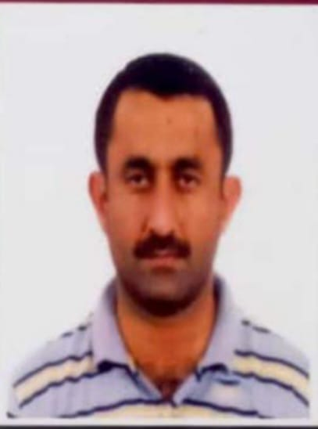Ex. Land Surveyor

Ministry of Municipality & Urban Planning - Qatar

 Bin Omran, Doha Qatar

* [buchal1@yahoo.com](mailto:buchal1@yahoo.com)

 33123887

**Objectives/Professional Summary:**

To acquire a challenging position and be an integral part of your esteemed Organization wherein I can develop my skills in the field of civil works and contribute positively. I have **22 years** of experience in **UAE, Qatar & Pakistan** in different well reputed Public / Private Organizations.

|  |  |  |  |
| --- | --- | --- | --- |
| Date of Birth | January 4th1974 | Citizenship | Pakistani |
| Education | Diploma in Associate Civil Engineering (***1994 to 1997***) | | |
| Driving License | Qatar Driving License | | |
| Equipment Handling Experience | GPS, Total Station, GIS | | |
| Leica Total Station 905, 705, 1105 | | |
| GPS Leica | | |
| VISA Status | Residence / NOC Available | | |
| Ashghal Approval | Highway Surveyor: ERCO 65651 / 194842 / 05  ERC 1400D20C1 / 3023 / 06 | | |

**Professional Experience:**

1. **Polaris Survey Company** - Pakistan - 1997-1999

**Position –** Surveyor

**Responsibilities**

* Layout of Sewerage and Drainage Pipeline
* Calculating and fixing invert of Drainage and Sewer pipelines
* Plotting of Cross-Section and Earthwork volume.
* Surveying for Planning of New Township
* Study and ranging out of Highways and Roads
* Layout of Bridges, Sewerages and Water Work Schemes

1. **Abu Dhabi Maintenance & Construction Co LLC - UAE - 2000-2004**

**Position -** Land Surveyor

**Responsibilities**

* Determines methods and procedure for establishing or re-establishing survey control.
* Design work for house connection and cover level for chambers and main holes.
* Responsibility of Roads and Building setting out.
* Calculation of vertical and horizontal alignment.

1. **Maunsell Consultancy Services Ltd** **- Qatar-** **2005-2010**

**Projects:**

**1.** ERC 0656 S1 SUHAIM BIN HAMAD STREET

Ref No. ERCO65651/194842/05

* **Details:**

Recreational Works of Asphalts Road and New Main Holes.

**2.** ERC 1400/D20 22ND FEB Street & Al Amir Upgrade & Interchanges

Ref No. ERC1400D20C1/3023/06

* **Details:**

Construction of New Road with 2 underpasses and 2 flyovers.

**3.** Land Topographical Surveyor in RSED (QAF)

Ref No. MD/EA/96002204.50/L 6413

**Details:**

All Survey work including Setting out & Topography with GPS

**4.** Al Khor Project Package 4 (96007807.50)

* **Details:**

New Villas (Housing Project)

**Responsibilities**

* Plans, organizes, coordinate and directs work of survey crew engaged in surveying land’s surface to determine precise location and measurements of projects of points, elevations, lines, areas and outline of areas for construction.
* Keep detailed and accurate records of crew activities, field survey data and develop new data from photogram metric records.
* Reports on events and activities which affect the survey and assumes legal responsibility for completed work.
* Study operational problems and recommend changes, coordinates findings with work of engineering and architectural personnel, clients, and other concerned staffs of the project.

1. **Ministry of Municipality & Urban Planning - Qatar 2010-2021**

**Position –** Surveyor and Inspector

**Achievements while Working**

1. Completed GEMS & ArcGIS I
2. Participation in Ninth Gulf Municipal Work Conference

**Responsibilities**

* Road Maintenance Inspector.

1. Main Doha City Link Road Maintenance (Asphalts, Patching, Milling Work Supervision).

* Demolish Building Inspector.

1. Inspection of Critical Situation of Old Buildings.

* Excavation Permit Inspector.

1. Inspection of Project Site and Issuance of Excavation Permit.