**Alava, John Kenneth D.**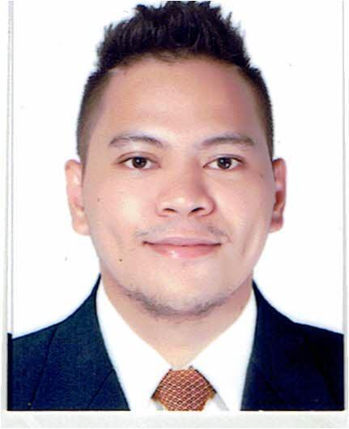

Home Address: Villa 30 al Tabari Street, Fereej Bin Omran

Doha, Qatar

Email Address: johnkennethalava1108@yahoo.com

Contact Number: (+974) 30147249

**BMS Operator FM (with Driver’s License)**

**WORK EXPERIENCE**

**February 2023 – Present Freelancer**

**March 2019 – October 2022**  **Assiyana Facilities Services**

*Dolphin Energy Tower, Doha, Qatar*

**BMS Operator (FM)**

**December 2016 – July 2018** **Bestech Building Technologies Corp.**

*Taguig City, Philippines*

**BMS Technician/Fire Alarm Technician/Telecom Technician**

**June 2012 – February 2016** **Qatari Computer Systems (Q-Soft)**

*Najma, Doha, Qatar*

**BMS Technician/AV Technician/Telecom Technician**

**BRIEF JOB DESCRIPTION**

**Assiyana Facilities Services & Bestech Building Technologies Corp.**

**General Duties and Responsibilities:**

***Dolphin Energy Tower, Doha Qatar***

***BMS Operator***

* Responsible for proactively identifying improvements to the system to reduce BMS-related plant and system failures and to improve the efficiency of the client estates.
* Responded to clients’ queries regarding issues at respective sites.
* Maintained and updated Daily Reports and submitted them to the Site Manager.
* Maintained and updated reporting dashboard for monthly client reporting.
* Maintained accurate records of all tasks undertaken
* Troubleshoot, serviced and replaced Fire Alarm Systems.
* Testing and servicing Fire Alarm Systems.
* Reported project status.

**Projects Handled as BMS Operator:**

* **Building Management System**
* Preventive maintenance of TCX Controller and EMX Expansion.
* Monitoring of the BMS.
* Monitoring of Cooling tower, AHU, and Genset.
* Replacement of TCX controller, field wiring, cable pulling of combus.
* Scheduling of the AHU according to client/tenant’s request.
* Reporting of project status.

**Qatari Computer Systems (Q-Soft)**

**General Duties and Responsibilities:**

* Performed cable termination which was instructed by a Professional / Senior BMS Engineer to prevent accidental contacts on wires in Motor Control Center (MCC) Panels or Digital Direct controllers (DDC) Panels.
* Troubleshooting on hardware component malfunctions and mechanical system applications.
* Maintained all processes and procedures by company/contract procedures.
* Worked with professional engineers and client representatives to demonstrate the proper functionality of the BMS System.

**EDUCATIONAL BACKGROUND**

***Technical Courses Taken:***

Nov. 25, 2017 – Dec. 3, 2017 **Basic Occupational Safety & Health for the Construction Industry (COSH)**

Ovaldesk Inc.

Asprec- Manalo Occupational Safety & Health DOLE, Quezon City, Philippines

Feb. 26, 2012 – March 16, 2012 **Pneumatic Industrial Controls**

March 19, 2012 – April 3, 2012 **Electro Pneumatics**

April 10, 2012 – April 26, 2012 **Programmable Logic Controls**

MFI Foundation, Inc.

MFI Building, Ortigas Avenue, Pasig City Philippines

***Secondary Education:***

2006 – 2009 Eusebio High School

Rosario, Pasig City