
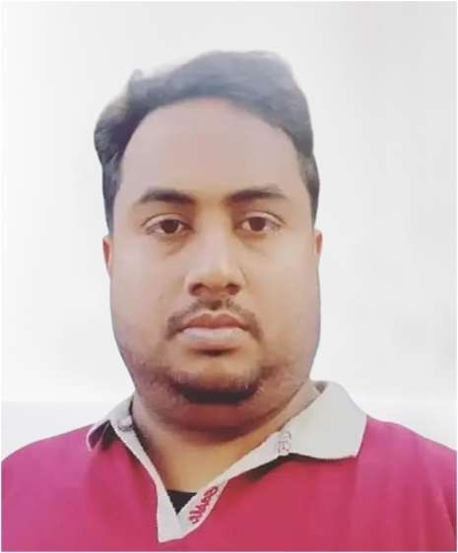
Resume
C O N T A C T
+974730219139
QATAR -DOHA
LOKMAN HOSSAIN

OBJECTIVE
I would like to work proper responsibility which will utilize my talent and provide me the wider opportunity to develop a carrier in a challenging an dynamic environment to ensure proper satisfaction with achievements based on quality performance

PERSONAL INFORMATION

- Full Name : LOKMAN HOSSAIN
- Nationality : BANGLADESH
- Date of Birth : 10/07/1984
- Gender : MALE
- ID NO : 28405008736
- Validity : 18/08/2024
- PASSPORT NO : EL0305480
- Validity : 31/01/2028
- Phone number : +97430219139
- Email : lokmanhossain0890@gmail.com
- DRING LICENSE: Light Driving license

- Appearing decent and well-behaved
- SKILLS
- The ability to deal with other nationalities
- Team work and co-operation
- The ability to communicate and interact with others
- Endure the hardships of science and work under any pressure
- Good hard worker
  - EXPERIENCE
- 10 Year of Working experience as a Driving in Qatar
- 1 Year of experiences as a Talabat Driving in
Qa t ar
- 5 Ye a r of Work in g Exp erien ce s as a ca rriage in Qa t ar

  - Education
- S.s.c Bangladesh

LANGUAGES KNOWN
- Arabic
- English
- Hindi
- Bangla
Declaration: I hereby certify that all above mentioned information are true and Correct to the best of my knowledge and belief, May I hope Kindly you will give a Chance for a better job.

Declaration
I hereby certify that all above mentioned information are true and correct to the best of my knowledge and belief, May I hope kindly you will give a chance for a better job.

