**OBJECTIVES:**

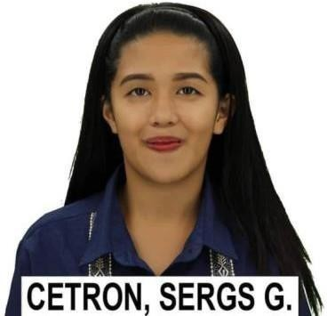

**SERGS G. CETRON**

**Current address:** 1390 Bambang street, Brgy. 265, Manila

**Cellphone:** 09126497071

**Email Address:** [cetronsergs1@gmail.com](mailto:cetronsergs1@gmail.com)

**Birthday**: September 28, 1996

**Age:** 28 years old

To obtain experience in organization that will nurture me about the things while working in diverse environment. To give service to the clients and customers that I will meet. To have exposure to different standard operating procedures, policies, and practices of the organization I belong to.

**PERSONAL INFORMATION**

**Religion:** Roman catholic

**Civil Status:** Single

**Date of Birth:** September. 28, 1996

**Citizenship:** Filipino

**Languages can Speak:** Tagalog and English

**Height:** 5’0

**SKILLS:**

* Leadership
* Communication
* Ability to work under pressure
* Time management skills
* Creative thinking skills

**EDUCATION:**

2021 - 2023 **The National Teacher College**

Bachelor of Science in Office Administration

Second Year - Second Semester

2017 – 2018 **Golden Success College Senior High school**

Strand: Accountancy, Business and Management

2010 - 2011 **Cayetano Arellano High school WORK EXPERIENCES:**

**HOMEWORLD SHOPPING CORPORATION**

Position: Sales Clerk

Date: April 2022 – October 2024

Address: SM NORTH EDSA

**JOLLIBEE FASTFOOD**

Position: Casier / Dine in

Date: January 2018 – May 2020

Address: Hidalgo Quiapo Manila

2015 _ 2017 Factory Worker – Soldering

Sx- E Commerce Inc. Bulacan city

**VOLUNTEER:**

2023 - present **Manila Fire & Rescue Volunteer, Inc.**

**SEC Reg. No. CN2019536-41**

**Fire Fighter/Medic Trainee**

**I HEREBY CERTIFY THAT THE ABOVE INFORMATION ARE TRUE AND WRITTEN WITH THE BEST OF MY KNOWLEDGE.**



Sergs G. Cetron