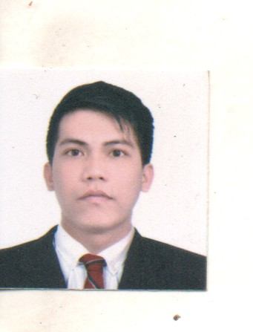
RONNEL E. ABDON
Purok 1Brgy. Callos Peñaranda,Nueva Ecija
+639127785808/09935496175

Objectives
To become part of your company in rendering with completive quality and honest in service.
Personal Information
Age: 30 years old
Birthday: October 24,1993
Birthplace: Peñaranda,Nueva Ecija
Height: 5'5
Weight:. 69kg
Religion: Catholic
Citizenship: Filipino
Country. : Phillipines
Civil status: Single
Dialect: Tagalog, English,
Mother's Name: Janet M. Abdon
Father's Name: Rolly C. Abdon

EDUCATIONAL BACKGROUND
ELEMENTARY Callos Elementary School
Callos, Peñaranda Nueva Ecija
2000-2006
SECONDARY Peñaranda National High School
Peñaranda,Nueva Ecija
2007-2011
TERTIARY Peñaranda Academic Extension Campus
Bachelor of Science in Information
Technology
Under Graduate
2011-2012
Work Experience
Silangan Industrial Park, Canlubang,Calamba City,Laguna
December 24,2011-May 30,2012
Position: Packer
LESLIE CORPORATION
4 Dama De Noche Subdivision 4 Paranaque 1731,Metro manila
November 25,2012-April 25,2013
Position: Production Operator

SANFORD Marketing CORP.
Save More,Amigo Burgos Avenue Melencio st.Cabanatuan City Nueva Ecija
November 21,2013-April 20,2014
Position: (Bagger)
Triple 8 Auto Seat Cover INC.
(Ace hardware Phil's )
Silang Cavite
May 2014-May 2023
Position:Sales Executive/Merchandiser/Installer Car seat Cover
RomacGroup(Yokohama Tire Phil's)
Clark Freeport Zone Angeles Pampangga
Position:Studding Operator
May 25 2023-September 25 2023
Apollolightings Inc.(HandyMan)
NepoMall Angeles Pampangga
Position: SalesMan
September 28 2023- September 15 2024

Job Knowledge: Customer help All needed.Assist The Customer.
Stocks inventory.stocks Replenish.Inventory Of Stocks
Maintaining the Cleanliness of Stocks and Area
Stocks Good Display of Monthly Monthly Promotion
Customer Always First anything what are you Doing.
Hit the Monthly Sales Quota

Ability to Work: Hardworking,Positive attitude,Flexibility,
I can follow All Company Rules.I can Work Extended of Time.
Reability,I can work UnderPressure.
I'm a Responsible in My job.I Can manage My Time.

I hereby certify the facts contained above are true and complete to the best of my knowledge and belief.

Ronnel Abdon

