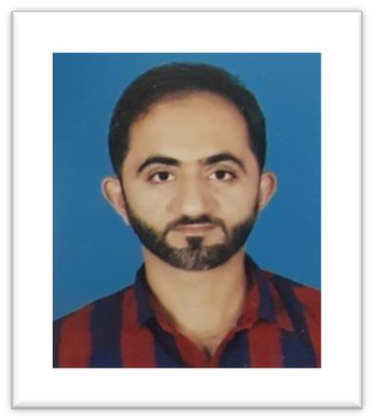

Adil

Hameed

Contact

**Address:**

Ar Rayyan, Doha, Qatar

**Phone:**

+974 5024 2342

**Email:**

[aadilqtr@gmail.com](mailto:christoper.m@gmail.com)

**Driving License:**

Yes

**Nationality:** Pakistan

**D.O.B:** 10/09/1988

**LinkedIn:** linkedin.com/in/adil-hameed- 9a2b6b120/

Professional Skills

Multilingual Friendly Personality

Hobbies

* Driving
* Learning
* Football
* Fencing

# Summary

Hands on knowledge and experience of the maintenance and support of computer systems and networks of both small and large departments. Valuable experience of planning, coordinating and controlling the security measures for information systems to regulate access to computer data files. Easy going by nature, willing to work shifts and able to get along with both work colleagues and senior managers.

# Education

|  |  |
| --- | --- |
| **06th standard** from Pakistan  Education Centre, Doha, Qatar. |  |

Experience

**PRO & Driver** – 10/2022 to date

**Bu Abed Decors**, Doha, Qatar

**Delivery** Courier – 04/2022 to 10/2022

**DHL** with third party **(QPost)**, Doha, Qatar

**Delivery** Courier – Since 11/2022

**Careem**, Doha, Qatar

**Delivery** Executive – 11/2020 to 02/2022

**Snoonu Trading & Services**, Doha, Qatar

**Admin & Supervisor (Talabat)** – 03/2020 to

09/2020

**Wagon Limousine**, Doha, Qatar

**Spectator Services**- 12/2019 to 01/2020

**Asian Gulf Cup & FIFA Club World Cup**, Doha, Qatar

**Fleet Coordinator** - 06/2016 to 03/2017

**Etisalat Academy**, United Arab Emirates

**Document Controller** - 04/2015 to 06/2016

**Etisalat Facilities Management**, United Arab Emirates

# Certification Courses

## Auto CAD Civil (Short Course)

**Vocational Training Institute**, Faisalabad, Pakistan

## Computer Applications

**K.M Computer Academy**, Faisalabad, Pakistan

# Declaration

I hereby declare that the above information is true and correct

to the best of my knowledge and belief.