**CURRICULUM VITAE**

***ZEESHAN HAIDER RANA***

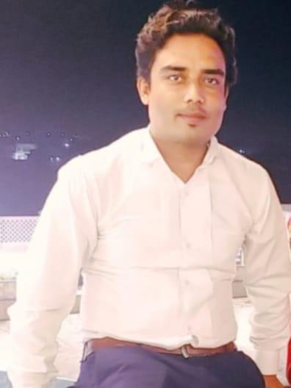

**Contact Address:**

15, Industrial Area, State of Qatar

Phone:  +974 71719216

**Languages**

* Arabic   – R-W-S

* English   – R‐W‐S

* Hindi     – R‐W‐S

* Urdu     – R‐W‐S

**Hobbies**

* Driving

* Photography

**Visa Status**

* Work Visa

* NOC Available

**Passport Details**

* Passport No.  :  AA697974

* Passport Validity :  21/01/2025

* Place of Issue  :   Islamabad

**Personal Details**

* Father’s : Muhammad shafqat

* DOB       : 22 May 198

* Sex       : Male

* Nationality: Pakistani

* Religion : Islam, Muslim

* Marital Status : Married

* Driver License: LMV Qatar

LMV KSA

* P Address  : Siyalkot, Pakistan

**Summary**

To employ for a job which utilize knowledge, skills, trainings and experiences in the field of Driver or even any other related work that provides high level of challenges and full range responsibilities through honest and quality services.

**Skill Highlights**

|  |  |  |
| --- | --- | --- |
| •Excellent Organization  •Leadership | • Time Management  • Dependability | • Efficiency  • Flexibility |

**Experience**

|  |
| --- |
| **Driver – 08/2024 to Till Now** |
| **M/s. Mowasalat (Karwa), State of Qatar** |
|  |
| **Driver cum Electrician and Plumber – 10/2011 to 02/2018** |
| **Blue Star International, Kingdom of Saudi Arabia** |

**Role and Responsibilities**

* Arrange transport for employees (wherever applicable) and maintenance company vehicle on data bases.
* Making and Handling paper in transport (Vehicle hand over & take over, Istimara inspection, Vehicle Insurance, Reminder Istimara to Driver).
* Managing for Vehicle status for fuel payment, status of Kms.

**Education**

* Plus Two U.P. Board of Examinations
* High School U.P. Board of Examinations

**Declaration:-**

I hereby declare that all the information provided above is true in all respects.

Place:  15, Industrial Area, State of Qatar

Date:  _____________________

**(Zeeshan Haider Rana)**