JAVANSHİR ALİYEV
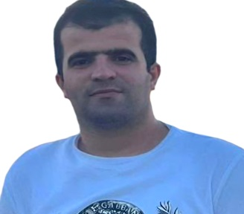 |  | Azerbaijan, Baku, Mashtaga, Khanlar settlement. AZ1039
 |  | +994512550419
 |  | cavansir 760@gmail.com

PROFESSIONAL SUMMARY | Energetic employee well-versed in strong communication and organization skills. Seeks solutions to problems and applies extensive analytical knowledge to findings. Adept at multi-tasking, leading group discussions and managing projects. Hard-working electrical and elektromechanical features with strong organizational skills. Achieves company goals through exceptional planning and prioritisation. Committed manager with exceptional leadership, organizational skills and communication abilities leads high-performing cross-functional teams. Leads projects, company operations and business growth. Dedicated experience of electromechanical work for 13 years demonstrate history of meeting company goals and promoting best practices. Adept at project planning and managing multiple accounts at once.
WORK HISTORY | ELECTRO MECHANIC (ENGINEER) 11/2016-Current  INTERNATIONAL AIRPORT NAMED AFTER H.ALIYEV, Baku , Azerbaijan  We can check and control flights, electricity, technical support for the airport, manage plane flights on the flight zone and lanes. We also control the main tools for departure, flight and land lanes for planes and helicopters. I also have some followinf features for the require job:  -Managed electromechanical system design , ensuring the appropriate selection of key components such as transformers, power modules, fuses and batteries.  -Established streamlined maintenance procudures, yileding significant improvcements in system uptime.  -Improve system functionality by conducting regular preventative maintenance on electrical systems.  -Designed electromechanical equipment for optimal performance.  -Collaborated closely with other engineers for efficient project competition.
SKILLS | -Communication  -Team building  -Leadership  -Public relations | -Resourcefulness  -Problem-solving  -Knowledge of Microsoft programmes
EDUCATION | National Aviation Academy, Baku, Azerbaijan. 09/2011-07/2015  Diploma of Higher Education: Electroenergetical Engineering.
LANGUAGES | English-elementary  Russian-elementary  Turkish- -intermediate
HOBBIES AND INTERESTS | To make the electrical system for buildings, ships, planes and their work lanes. Construction, designing, listening to music, reading scientific books.
REFERENCES | References available upon request.

