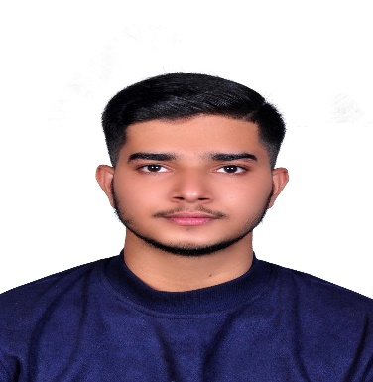

HARIS KANNACHAN KANDIYIL

Address:India,Kerala

Contract number:+974 71240821

Email Add:hariskkvanimel123@gmail.com

**SUMMARY**

Dedicated and trusted driver with honesty and hardworking ability.

Willing to work under pressure can handle hard situation.

Trustworthy and driving with safety precaution.

**JOB DESCRIPTION**

Delivered foods and supply

Picking and dropping staff

Preparing and taking order

**WORK EXPERIENCE**

Rajab Cafeteria

Waiter

Delivery Driver

May 5,2023 to September 30,2024

Al Mashar St,Doha

Sea Shell Jabal Al Rahma Cafeteria

Waiter

Delivery Driver

February 18,2021 to February 17,2023

UAE

**EDUCATION**

Cerscent High School Vanimal

April 15,2005 to March 5,2017