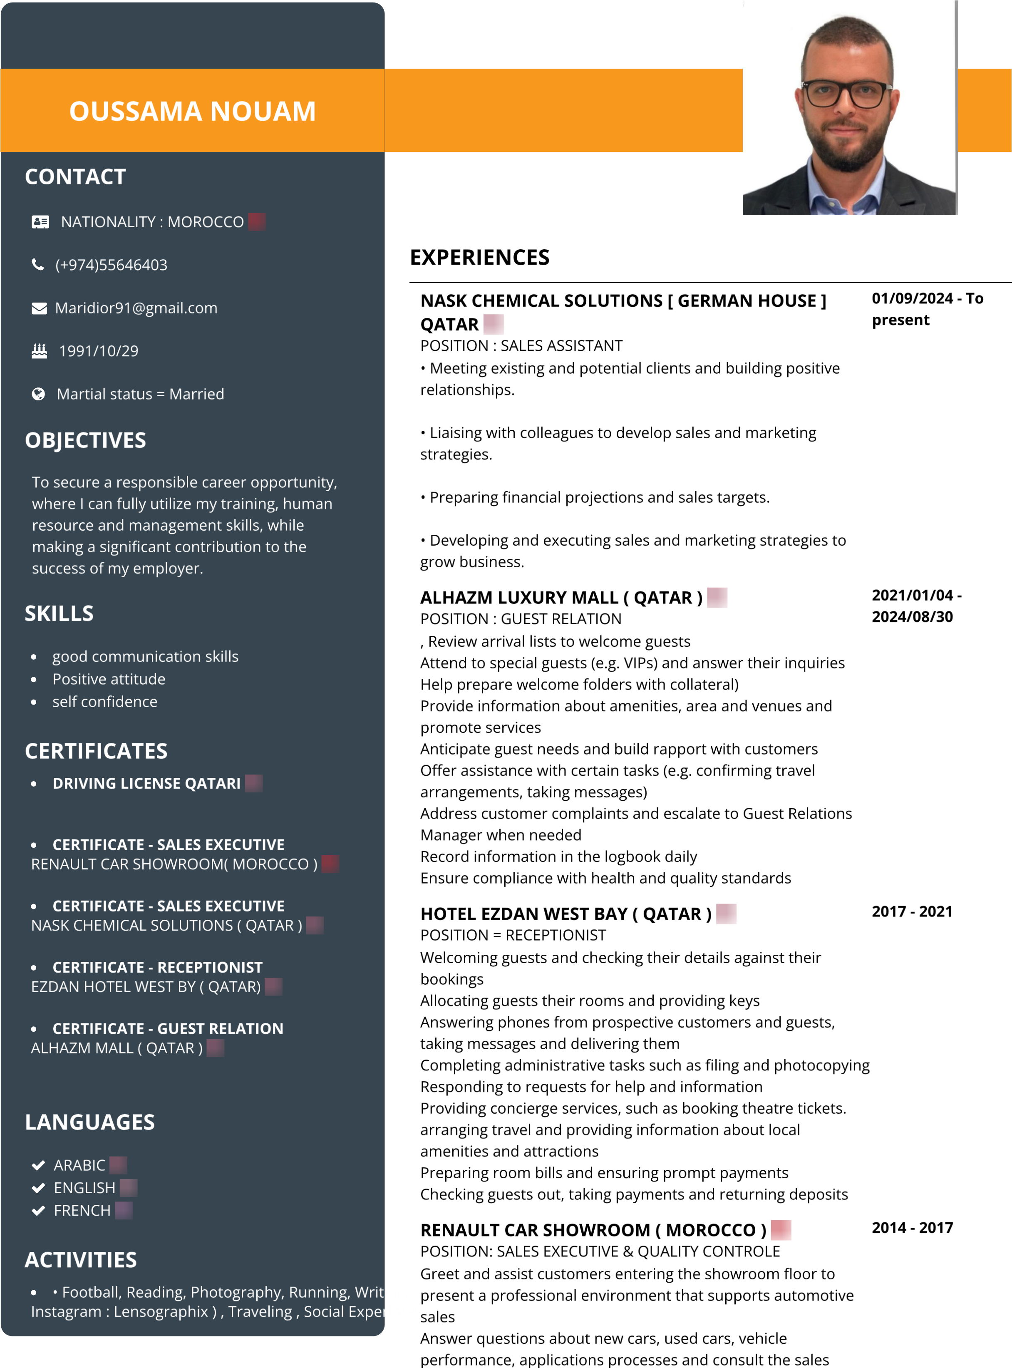

manager as needed

Employ strong communication and interpersonal skills to build rapport when assisting potential customers with their vehicle selections

Maintain an up-to-date customer database to drive current and future automotive sales

Present used and new cars through test drives, demonstrations, and dealership walk-throughs

**MARIDIOR FACTORY** 《 **MOROCCO } 2011 - 2014**

POSITION: SALES ENGINEER

Sell the company’s products by implementing sales plan, To be aware of complete product range that can be offered to client. To have full awareness of products through brand catalogs and technical data sheets.

· Ability to achieve assigned monthly budget for the product brand / category.

· Responsible for achieving monthly sales target, daily customer site visits and weekly customer site visits, number of daily activities/tasks, call quality, appointment setting potential clients who are good in payments etc. · Initiates and coordinates development of action plans to penetrate and create clients (traders / new end-users). · Ability to represent in exhibitions for the brand associated with company.

**EDUCATIONS**

|  |  |
| --- | --- |
| **ABDELKARIM ALKHATABI**  BACHELOR'S  Science Physics | **2009/2010** |
| **OFPPT MOROCCO** | **2010/2012** |

DIPLOMA

AUTOCAD INDUSTRY