**CURRICULUM VITAE**

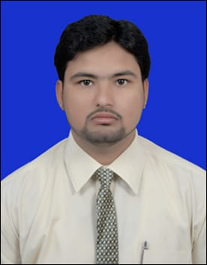

**Mohd Sajid Ali Razvi**

Mobile: +91-7207558372, Email: [sajidrazvi14@gmail.com](mailto:sajidrazvi14@gmail.com)

**OBJECTIVE:**

Looking for a challenging position in Marketing Domain, utilizing abilities developed through my experience, training and education, with the opportunity for professional growth based on performance and merit in a dynamic organization.

**WORK EXPERIENCE:**

**Organization: RKS MOTORS Nampally**

**Designation: Driver 2013 to 2017**

**Organization: BANK OF AMERICA**

**Designation: Driver 2018 to 2020**

**Organization: DOHA QATAR AL WAHAB COMPANY**

**Designation: Driver 2021 to 2024**

**Educational Qualifications:**

|  |  |  |
| --- | --- | --- |
| Course | College | Year |
| intermediate | Sree Vani junior college | 2010 |

**Computer skills:**

Diploma in Computer Hardware Engineering and Network

|  |  |  |  |  |  |  |
| --- | --- | --- | --- | --- | --- | --- |
| **Software Proficiency:**   |  |  | | --- | --- | | Applications | MS-Office 97 & 2000, Front Page, Page Maker | | Browsers | Netscape Navigator, Internet Explorer | | Operating Systems | DOS, Windows 95/ 98/ ME/ 2000/ XP/ NT | |

***PERSONAL PROFILE***

**Father’s Name** :Late,Mir Irshad Ali Razvi  
**Date of Birth** : 22 June 1992  
**Nationality** :Indian  
**Birth Place** :Hyderabad (A.P)  
**Language**  :English, Urdu, and Hindi

**Passport**, **no :**Y5020144

**Driving LNO. :**TS01120160013427

**DOHA QATAR DLNO. :**29235649713

**Address** :Flat no 200(D) 1st Floor, Madina complex,Noor Khan Bazar,

                                      Hyderabad (A.P) India-500024

***Mohd. Sajid Ali Razvi.***