

**Name : Md. Fahisatul Azad Fahim**

**Cell : +974 30422620(WhatsApp)**

**E-mail : fahimcrush7@gmail.com**

***CAREER OBJECTIVE*:**



To be a person with challenging in which hard working and creativity in necessary as well responsibilities and can show leadership quality with communication skills & development.

***EDUCATIONAL BACKGROUND:***

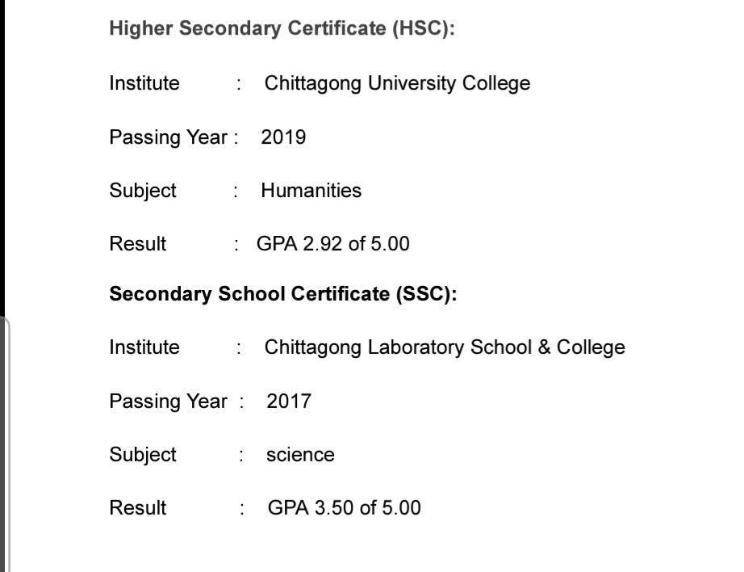

***COMPUTER SKILLS:***

* Bengali, English Typing
* Office Management.
* Computer Hardware & Troubleshooting.
* E-mail & Internet Browsing.

**STRENGTH**:



* Capable to work under pressure
* Able to co-ordinate & work effectively in a group
* Goal Oriented and Hard Working.
* Self-Motivated.
* Planning and Organizing Ability.
* Ability to adapt in new environment & love to take challenge.

**INTERESTS**:



* Traveling, Reading and Public Relation.

**EXPERIENCE:**



* 6 Months Experience as a **Waiter cum cashier “The Peninsula hotel”** inChittagong Bangladesh
* 1 Year Experience as a **Cashier** **“Ahyan expending”** inDoha Qatar
* 1 Year Experience as a **Waiter cum Cashier of SOS CAFÉ & REST, Doha Qatar**
* 1 Year Experience as a **Delivery Rider at Rafeeq Al Darb Trading Services & transportation**

**LANGUAGE PROFICIENCY**



✦ Bangla, English & Hindi.

**PERSONAL DATA:**



| Gender | : Male |
| --- | --- |
| Date of birth | : 15th January 2000 |
| Religion | : Islam |
| Nationality | : Bangladeshi (by birth) |
| Marital status  Visa  Driving license | : Unmarried  : Qatar resident permit  : Car |

**CERTIFICATION***:*



I certify that all information stated in this resume is true and complete to the best of my knowledge. I authorize to verify the information provided in this resume

**MD FAHISATUL AZAD FAHIM**