Curriculum Vitae 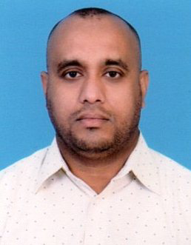

**Personal Information**

Name : **Abu Nahen**

Date of birth : 15 May 1980

Contract : 974 30715363

Address : Feeroj Abdul Aziz, Doha-Qatar

E-mail : abunahen123@yahoo.com

Driving License : Light

Sex : Male

Passport No : A13395229

Marital Status : Married

Religion : Islam

Nationality Bangladeshi

**Career Objective**

To Obtain a Position that will allow me to utilize my technical skills. Experience and willingness to learn in making an organization successful.

**Educational Qualification**

**Bachelor of Commerce (B.Com)**

Name of College : Govt. Commerce College

Board : Chittagong, Bangladesh

Result : 2nd Class

Passing Year : 2001

**Higher Secondary Certificate Exam (H.S.C)**

Name of College : Govt. City College

Board : Chittagong, Bangladesh

Result : 2nd Class

Passing Year : 1998

**Secondary School Certificate Exam (S.S.C)**

Name of School : Haid Chakia High School

Board : Chittagong, Bangladesh

Result : First Class

Passing Year : 1996

**Work Experience**

* **Company : Inn style Fashion in Chittagong**

Post : Store Keeper

Duration : 02 Years

* **Company : Univogue Germens Ltd**

Post : Commercial

Duration : 03 Years

* **Company : Masakin Trading & Contracting Co.**

Post : Driver,Electrical Work.

Duration : Running Till Now.

**Language Proficiency :**

English, Hindi, Bangla, Worker able Arabic

**Abu Nahen**

**Signature**