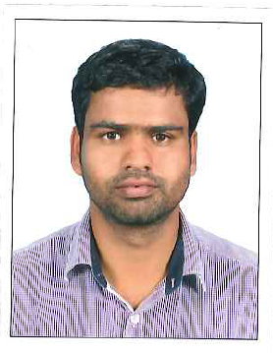
ABDUL LATHEEF.M
P.O. Box: Doha, QATAR
Mobile: 00974 30 02 83 23
E-mail: latheekdy@gmail.com

Application for Driver

CAREER OBJECTIVE:
Looking for an opportunity to utilize my skills and abilities in a right organization that offers professional growth while being resourceful, innovative and flexible.
EDUCATIONAL QUALIFICATION:
- Plus two in 2000-2002 (V-Tech College)
Education Department State of Kerala, India
- SSLC Passed in 2000
Government High School, Neeleshwaram,
Kozhikkode, Kerala, India
SOFTWARE & COMPUTER PROFICIENCY:
- MS Office
- Diploma in Computer Applications
- Internet
SUMMARY OF EXPERIENCE:
Over 10years of Experience in Driving, Salesman and Messenger
- Light driver (w/Qatar Driving License)
- In charge of sim card activation
- Sim card distribution on other branches
- Promodizer
- Scheme communication
- Document submittal
WORKING EXPERIENCE:
June 2011-Till Date AGA-MEP
Position Held : Driver cum Messenger
Project:-
US AIR BASE QATAR STRATEGIC MILITARY FACILITIES
Main Contractor: I.C.G.M.Ltd

COMPANY
Sep-2003 – April 2011 IDEA CELLULAR LIMITED
KERALA,INDIA
Position Held : Marketing Executive
COMPANY
Sep -2002 – Aug-2003 NICODAS MARKETING COMPANY
KERALA,INDIA
Position Held : Marketing Executive

PERSONAL STRENGTHS:
- Excellent Communication
- Ability to work for sincere and confident
- Dedicated, hard working and self-reliant.
- Organizing and performing group items
HOBBIES:
- Playing Foot ball, Chess & Cricket
PERSONAL DETAILS:
Father’s Name : Ali
Date of birth : 11.10.1985
Sex & Marital Status : Male,Married
Nationality : Indian
Languages known : English, Hindi, Malayalam, Arabic
(Read & Write)
PASSPORT & VISA DETAILS:
Passport Number : H 1615187
Place & Date of Issue : Kozhikode 17-12-2008
Visa status : Residence –Transferable
qatar driving license:
: First issue-2011-04-12
: Validity-2016-04-11
Permanent Address:
Melepattu House
Thiruvambadi Road Omassery

Phone: 0091 96 05 16 90 10
DECLARATION:

I hereby declare that the above information given above is true to the best of my knowledge and belief.

Abdul Latheef
Driver cum Salesman and Messenger

