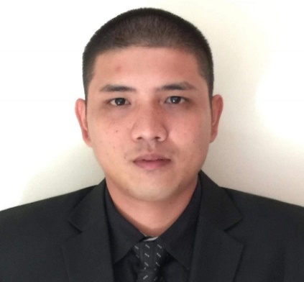
- Doha, Qatar
- raiko24@yahoo.com
- +947-70199510
AIKO R. ROMERO




Work experience
Summary

SECRETARY
ASPETAR, REHAB DEPARTMENT
DRIEAH LOGISTICS CO. WLL
June 2024 - Present

- Act as the first point of contact for physiotherapists and queries from other departments, face to face or by phone or email, taking responsibility for providing accurate information and general advice/guidance, in a timely and effective manner.
- To be responsible for arranging the daily schedule of the physiotherapist with the patient.
- To be responsible for arranging meetings and leave.
- To be responsible for maintaining confidential medical records (electronic and paper) and complying with data protection regulations.
- Maintain and update patient details and appointment details on the systems.
- Preparing reports of the total number of patients daily.
- Answer phone calls and forward them to relevant staff members.

STOREKEEPER
YADOO FACTORY
2018 – 2024

- Encoding data; counts, grades, expiry dates and weights.
- Check incoming orders against items listed on requisitions, invoices, or other forms.
- Responsible for receiving, loading/unloading, and counting stock items.
- Pack/unpacks items to be stocked in stockrooms, store items in an orderly and accessible manner.
- Periodically verify inventory computations' accuracy by comparing them to physical counts of stock, investigate discrepancies and adjusts errors.
- Supervise staffs and keep records of sales.

Qatar License

- Deal directly with clients either by telephone, electronically, or face-to-face
- Respond promptly to client inquiries
- Obtain and evaluate all relevant information to handle service inquiries
- The ability to plan your work, work on your initiative, and meet deadlines
- The ability to manage pressure and conflicting demands and priorities tasks and workload

Associates in Hotel & Restaurant Management
St. Therese MTC College,
Ilo ilo Philippines
S.Y. 2010 - 2013

Skills
Education
Highly ambitious, hardworking, and organized individual who enjoys practicing discipline and high attention to detail to my work. I am highly motivated and willing to learn new skills and improve what skills I already possess.
With Automatic Vehicle License

ADMINISTRATIVE CLERK
HAMAD MEDICAL
AMWAJ CATERING SERVICES
2013 – 2018

- Manage the ordering system to include placing orders either online or by phone, receiving all orders, updating ordering sheets
- Responsible for receiving calls and requests from clients.
- Arranging the schedule of bookings of events.
- Updating the schedule for catering orders.
- Provide support to the head chef and catering team by giving them details such as an ordered menu, number of Pax, time, date, and location.
- Maintain communication between department heads, chairs, medical staff, and relevant external organizations.

MERCHANDISER
Macro Supermarket
Ilo Ilo, Philippines
2013 – 6 months

- Responsible for ensuring the products are properly stocked, displayed, and readily available on supermarket shelves.
- Responsible for the preparation of reports, actual inventory, process purchase orders, promotion of products, and executes sales strategies to meet the required sales targets.
- Analyze sales figures, customer reactions, and market trends to anticipate product needs and plan product ranges/stock
- Collaborate with buyers, suppliers, distributors, and analysts to negotiate prices, quantities, and time-scales
- Maximize customer interest and sales levels by displaying products appropriately.

I hereby swear that the above statements are true to the extent of my knowledge and ability.

