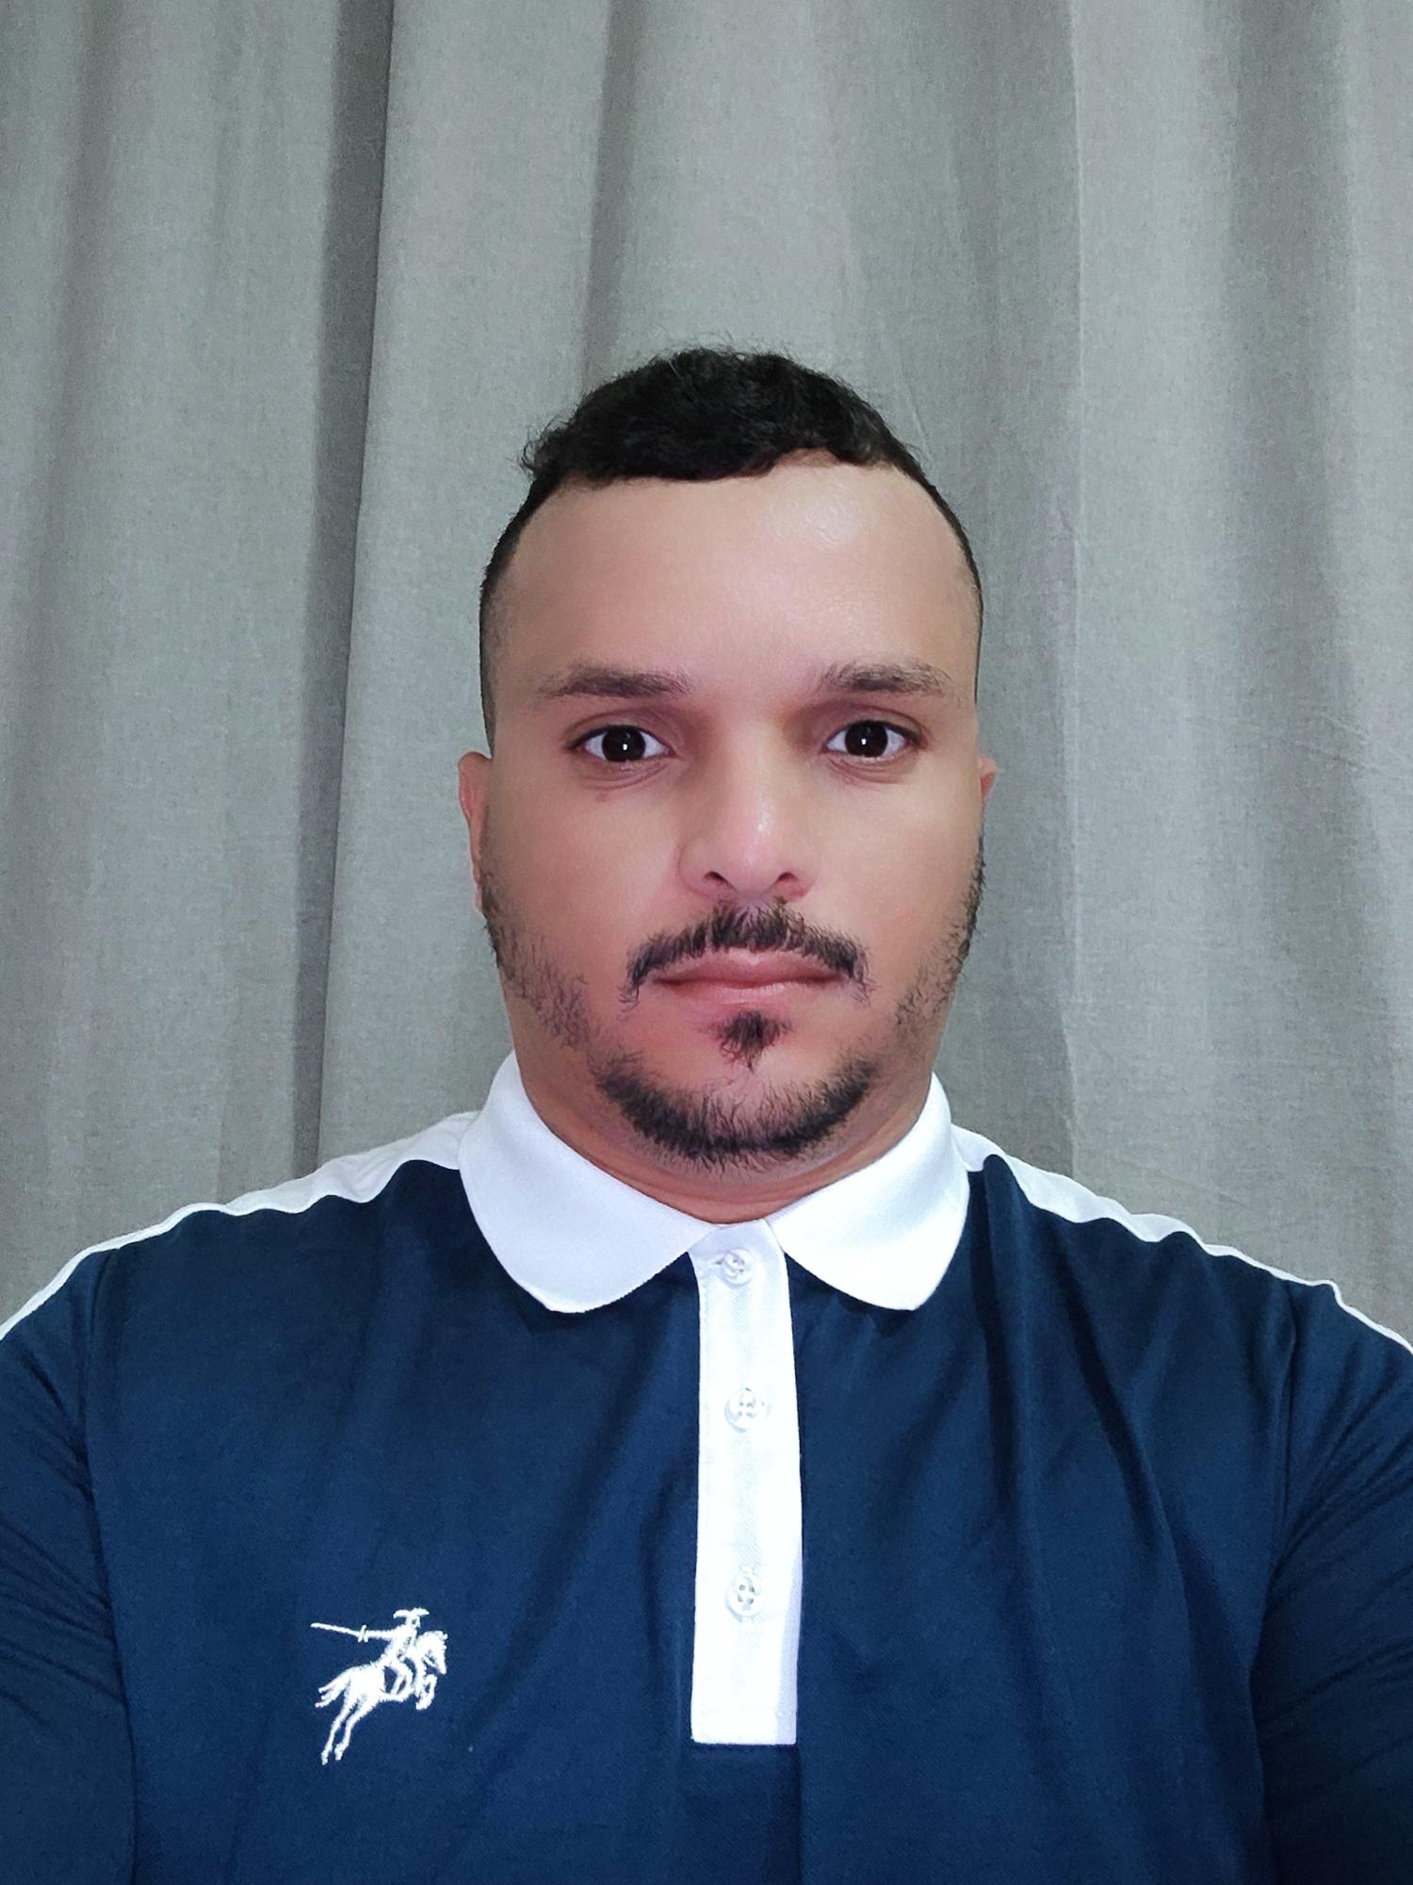

Curriculum Vitae

Personal Information

Name : **Soufiane Haddam**

Date of birth: : 12/09/1990

Nationality : Moroccan

Marital Status : Married

Address : Al Aziziyah – Qatar

QID numbre : **29050401343**

Mobile No. : **+97455605653**

E-mail : haddamsoufiane30@gmail.com

Visa status : **Valid with NOC**

**License driver : b 2013 Morocco/ 2019 light Qatar**

Education

-2010-2012 Diploma of Technician

of Air conditioning from Institute

of Specialists in Thermal

Engineering and Refrigeration,

Morocco

-2010-2009 Secondary School

Equivalent, Experimental Sciences

Work Experience

**2012/2016**

* working 4 years maintenance and driver in Mr. Clim Company,**Morocco**

**2016/2018**

*working 2 years driver in Pistache for Wedding Company, **Doha – Qatar**

**2018/2021**

*-working 3 years marketing representative and driver in al yakhet elkhaliji company   
**alwakrah_Qatar**

|  |  |  |
| --- | --- | --- |
| **2021/2022** |  |  |

*Working driver and collection in company proheltcare and nursing

**02/2022 to 01/2023**

**Security and safety in security committee 2022 M**OI. **Qatar**

• 3-months training at the qatar police institute and work in the hotel during the event 2022 world cup .the team participating in the sporting.

**11/2023**

**I am currently working rixos hotel qetaifan island north/ meryalwaterpark Lusail ,Qatar.**

* **Guest Experience** Department in terms of transporting the guests within the waterpark/Hotel using buggies . This position is responsible to

operate the buggy inside the waterpark/Hotel to transport guests and colleagues safely.

Interpersonal skills

-Excellent customer service

-Establish solid business   
 relationship with customers   
-Cooperation and team work spirit   
-Commitment to execute tasks with   
 accuracy

Languages

-Arabic, French, English