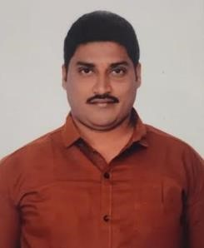**Maab Suban Shaik**

Driver

Performance driven Driver with 20+ years of experience in performing driving. Friendly and outgoing car driver proficient in safe operations, passenger transportation and inclement weather driving. Excellent communicator and problem-solver with a solid track record in the field. Outstanding safety background and consistency requested by repeat customers for regular transportation.

**maabsuban776@gmail.com || 00974 – 77623993 /66470558 ||**

**WORK EXPERIENCE :**

* Worked as a Driver for Iran Football Team & Netherland Football Team during FIFA EVENT -2022.
* 20 years’ experience as Light Driver/Assistance in Doha Qatar from 2003 till date.

**CORE QUALIFICATIONS :**

* Vehicle maintenance
* Route planning and GPS navigation
* Vehicle operations
* Safety regulations
* Excellent Communication
* Impeccable teamwork
* Good human relations

**EDUCATION :**

* Board of secondary education, Zpp High School. Andhra Pradesh, India

**LANGUAGES :**

* Arabic, English, Hindi, Malayalam, Tamil & Telugu

**PERSONAL DETAILS :**

|  |  |
| --- | --- |
| * Name | : Shaik Maab Suban |
| * Date of Birth | : 15/05/1977 |
| * Gender | : Male |
| * Marital status | : Married |
| * Nationality | : India |
| * Passport No | : N5376082 |
| * Date of Expiry | : 16/12/2025 |
| * **QID No:** | **: 27735600972** |
| * **Visa status** | **: Transferable(Work)** |

* **Driving License : Qatar Driving License**

**DECLARATION :**

I hereby declare that all the information given above is true to the best of my knowledge, and in the event of my appointment, I shall discharge my duties and responsivities. I will be sincere in my part of work.

Shaik Maab Suban

