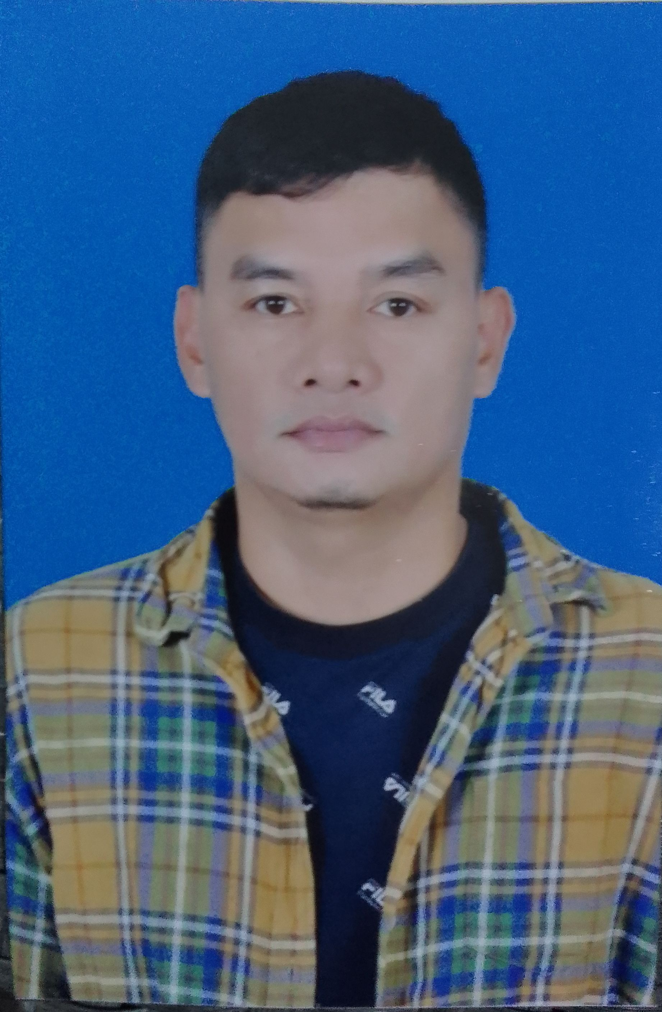
EDWIN C. REYES
Doha Qatar
+974 5010 9740
reyesedwin14.er@gmail.com

SUMMARY
Five (5) years driving work experienced,Currently work as private driver since April 2022, skilled and reliable driver with extensive experience working in the transportation of goods and passengers. Familiar with safe driving practices and traffic laws, And almost nine (9) years worked experienced in sales environment also manufacturing and office work.
PROFESSIONAL EXPERIENCE
Private Driver
ABDULRAHMAN AL MANA (Doha Qatar)
April 08, 2022 - Present

- Fetching and welcoming clients at the beginning of their trip.
- Loading and unloading clients' possessions, as required.
- Traveling via the most efficient routes, unless otherwise directed.
- Complying with road regulations at all times.
- Engaging in conversation or playing music, if suitable.
- Ensuring that the automobile remains clean and well maintained.

Production Operator
POWERLANE RESOURCES INC. ( SANYO DENKI PHILIPPINES, TECHNO PARK SBFZ )
October 08, 2020 – January 11, 2022
- Responsible to operate Nessie and Fanuc molding machine in production including the machine trouble and checked the product from the conveyor.
- Checked the measurement of shaft and rotor bush every hour to ensure standard size of product used the digital automatic indicator.
- Maintain the quality check time of the product including the inner and outer diameter of the impeller.
- Insert the shaft bush assembled in the molding machine with fast cycle time.
- Log the machine temperature including the metallic mold and hopper dryer to avoid product damage from molding machine.
- Fill up the checklist form every model made and also the downtime of molding machine.
- Check the drawing every model request including the shop order to ensure that the resin materials to be used are correct.
- Organized every product made in to the box base on the quantity from the ID note.

Dispatcher / Driver
TELE EMPIRE INC (SUBIC BAY FREEPORT ZONE, PHILIPPINES)
April 11, 2019 – July 15, 2020
- Organized all driver for them everyday route schedule
- Arranged the fuel purchase order and other all driver request
- Received and response to the company client request messages
- Booked the client request base on them schedule and destination
- Encode everyday transportation trip and update the pegasus system.
- Attend to the weekly meeting for the transportation department
- If lack of driver I was drive depends on the client request include Manila route.
Company Driver
GT GRAND TITANIC REAL STATE INC. (SUBIC BAY FREEPORT ZONE, PHILIPPINES)
May 2017 – February 2019
- Obeyed all traffic rules and regulation and reported all accidents immediately
- Transport Airport and Metro Manila to Subic vice versa, sometimes often depends the client request.
- Monitoring safe vehicle conditions and reporting the number of speed kilometer to trace next vehicle maintenance.
- Assisted and recommended procedures for improving client satisfaction, driver safety, and company efficiency.
- Developed rapport with clients to improve communication between loading crews and drivers and emphasize appropriate safety measures.
- Use communication mobile phone to coordinated and monitor day to day operation.

Admin Clerk
SAUDI OGER LTD ( JEDDAH KSA )
September 2014 – November 2016

- Responsible to lead the building room inspectors, prepared the weekly & monthly room inspection report.
- Prepare the monthly occupied & vacant template include the offices, workstations conference rooms, huddle room & cubicle room.
- Collecting the checklist from the room inspectors & filing them in the files.
- Categorizing the room inspection report based on the highlighted problems (Space Planning, Furniture, Housekeeping, IT, electrical & Digital clocks) for the teams in charge.
- Convert weekly& monthly room inspection excel sheet report to PDF then upload it to Maintenance Services.
- Operate office machine, such us photocopiers and scanners and personal computer.
- Answering phones and greet the clients warmly, Send and receive email from the campus client include the manager & building inspectors.
- Update daily room inspection projects & services tracking sheet and room inspection statistic.
- Survey the office for the space occupancy readiness checklist to ensure the condition of office furniture, data port, electrical port, HVAC concern & maintenance issues.

Cashier, Sales Associate, Stock Clerk
ADIDAS OUTLET (SUBIC BAY FREEPORT ZONE, PHILIPPINES)
February 2009 – September 2014

- Responsible for accepting payment from the customers, giving change and receipts& selling product.
- Operate a POS cash register, handled 100 transaction daily on average, and count money to ensure the amount is correct.
- Knowledge and ability to refund items in the form of cash or credit.
- Bagged customer’s good’s in accordance to best practices, ensuring that their items do not get smashed or ruined in transit.
- Able to resolved customer complained a calm and intelligent manner.
- Assisted customers,finding or selecting item.
- Stocked replenished and organized inventory with accuracy and efficiency.
- Received delivery item every 3rd week of month and encode them to inventory excel sheet.
- Deposit the money for store everyday sale.

Sale Associate
CHRIO HOUSE ESSENTIALS, INC ( SM LIPA CITY )
February 2008 – May 2009

- Responsible for selling products, check inventory to ensure product is in stock, ensure pricing is correct, set up display cases.
- Assist the customer and asked them for what they need
- Make order for the running out product and receive delivery
- Resolve the customer product change item

Merchandiser
HANDYMAN DO IT CENTER ( Sicaba Import & Export Corp. )
August 2004 – September 2007

- Responsible for selling products, merchandise, and services in a retail setting, such as Furniture, Hardware, Gardening, Plumbing and Auto accessories.
- Demonstrate products and show consumers how to maximize their features.
- Discuss warranties and replacement parts, Process orders in person and over the phone.
- Check inventory to ensure product is in stock, Ensure pricing is correct, set up display cases.
- Conduct outbound lead follow-up calls to potential and existing customers via telephone and e-mail to qualify leads and to sell products and services.
Service Crew
CARSON FOOD CORP. ( CHOWKING LIPA, BATANGAS )
July 2001 – October 2001

- Greet all customer entered the store
- Assisted the customer to the vacant table and after that get what they order
- Served the food for the customer
- Prepared all condiments before store operation and clean the store after store hours

Service Crew
RICHMOND FOOD CORP. ( JOLLIBEE LIPA, BATANGAS )
October 2000 – March 2001

- Greet all customer entered the store
- Assisted the customer to the vacant table
- Served the food for the customer
- Prepared the store before opening and clean it after store hours

EDUCATION
LYCEUM OF BATANGAS
Batchelor of Science in Marine Transportation
Undergraduate, College, 2002

BAYORBOR NATIONAL HIGH SCHOOL
Diploma, High School, April 2000

ADDITIONAL SKILLS

- Strong driving record, efficiency and time management, problem solving, documentation, data entry, listening and verbal communication,technology, attention detail, team player, sales and marketing, customer service

CHARACTER REFERENCES
Ahmad Aluzom
Key control Manager
King Abdulah University
Thuwal Jeddah Saudi Arabia
Mobile # +966 561007133

I hereby declare that all above mentioned details are true to my knowledge and belief.

Edwin C. Reyes
Applicant Name

