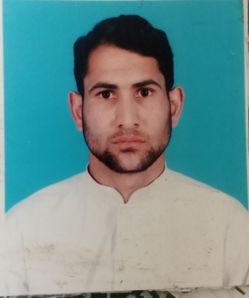
RASHID KARIM
Electrical technician
Email: karimrashid010@gmail.com
Mob: +974 70745673

CAREER OBJECTIVE
To secure a position where my hard work, dedication and the ability to acquire new skills will advantage any company & work honestly and achieve a responsible and challenging position, where my potential matches the organization's requirement and to contribute to the goal and grow with the organization.

PROFESSIONAL EXPERIENCE (12+ Years)

AKTOR COMO INTERCITY FM, Qatar

Doha Metro Project

Electrical Technician Jan-2022 to till date

CREATIVE TECHNOLOGIES, Pakistan

Sr. Electrician Oct-2020 to Dec-2021

MILLENNIUM HOTEL, Pakistan

Electrician Oct-2019 to Apr-2020

REDCO INTERNATIONAL COMPANY, Qatar

Electrician Mar-2018 to Jun-2019

MARGALLA HOTEL, Pakistan

Sr. Electrical technician Feb-2016 to Feb-2018

RAMADA WORLDWIDE HOTEL, Pakistan

Electrical technician Mar-2013 to Feb-2016

NAZIM CONSTRUCTION COMPANY, Pakistan

Electrician Nov-2011 to Dec-2012

PROFESSIONAL SKILLS
- Inspection and maintenance of MEP and HVAC systems for high rise buildings, Hotels and metro stations
- Single phase and 3-phase motor, control panel and VFD maintenance.
- Monitoring and operation of all equipment’s through BACS
- Perform maintenance of Electrical systems (replace and repair lights, power sockets, circuit breakers, Distribution panel boards, submain distribution boards, mcc panel)
- Maintenance of AHU, FCU, CRAC and Heater.
- Maintenance of kitchen appliances and home appliances like fridge, washing machine, microwave Owen, vacuum cleaner, floor polishing machine etc.
- Generators maintenance
- Repair and maintain Tissue holders, faucets, water tape sensor, soap and sanitizer dispenser.
- Trouble shooting and testing of all types of motors, compressors and all electrical and electronic equipment’s with meggers, multimeter and clamp meter
- Electrical wiring and installation (light & power)
- UPS installations
- Terminates the wire connections, DB and SMDB installation and termination, cable glanding
- Installation and testing of motors and pumps
- Sound knowledge in use of megger, multimeter and clamp meter

EDUCATION QUALIFICATION

- MATRICULATION
Board of intermediate & Secondary education, Mirpur, AJK

- DAE Electricals
Allied Institute of Technical Training center, Pakistan

PERSONAL DETAILS
- Dob: 10-12-1993
- Gender: Male
- Marital Status: Married
- Nationality: Pakistan
- Passport: BH4951212
- Language Known: English, Urdu, Punjabi and Hindi

DECLARATION
I have declared that the above information is true and correct to the best of my knowledge and believe.

RASHID KARIM

