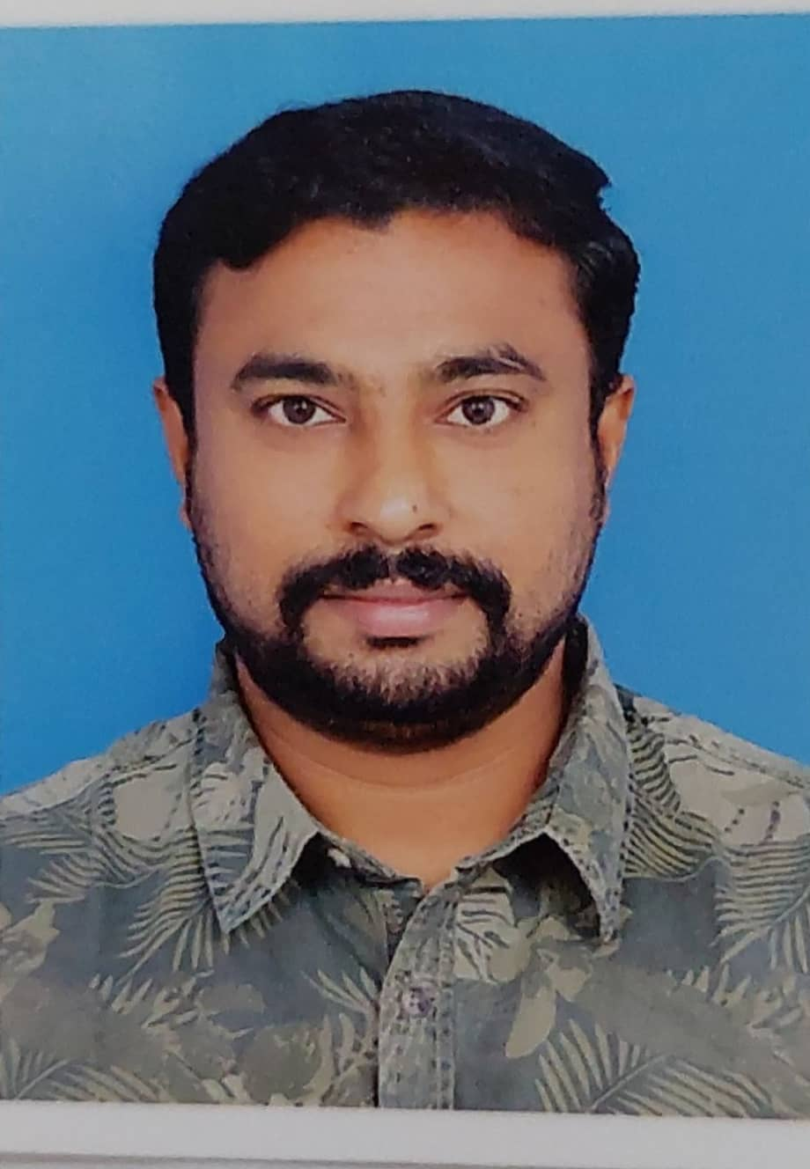 |  | Sijil Surendran  Professional Driver
Profile  Nationality: India  Marital status: Married  Hardworking and dedicated customer service. Grateful to follow orders and make sure customer service quality will be up to the mark. Offering 8+ years of experience in the industry and a passion for service excellence.  Contact  PHONE:  00974-70935551  EMAIL:  Sijilsurendran34@gmail.com  Identification  Passport no: M8620682  QID: 28635676489  Exp on: 05/2023  Qatar Driving license  From: 07/09/2021 to 06/09/2026  Covid-19 Vaccination  mRNA, LNP-S, Pfizer,30mcg/ 0.3 mL dose- 3 Doses |  | EDUCATION  Higher Secondary  2002 – 03/2004  ITI  2005 – 2007  WORK EXPERIENCE  Masoud project/ Al Ahmadiah (Abu Dhabi)  Electric Chargehand  Period of: 2007–2010  - Fujairah f2 Project/Alstom (dan way)  Electric Chargehand  Period of: 2010-2011  Al Hadhi hospital Saudia  Travelling supervisor  Period of: 2014-2018  - Press & Media  Sales executive  Period of: 2019-2021  Language

