Mubashir Hayat

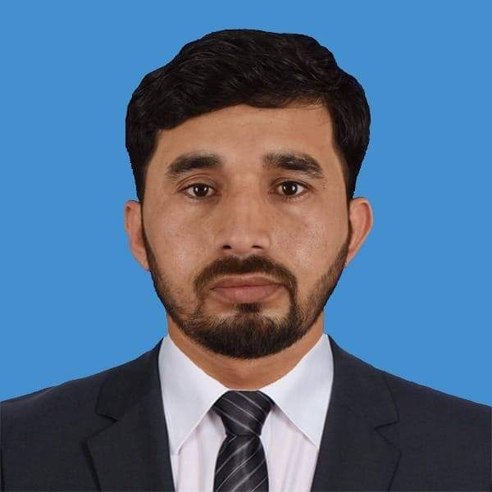
Job title: Storekeeper (MEP & Civil)
Total Experience: -7 years
Current Working: - Redco International Qatar.
Cell no. +974-33737516
Email adds: mubasherbhatti77@gmail.com
Qatar ID: 29658603877

- Objective

- Looking for a challenging position, which offers opportunities to utilize my background experience, Skills and enhance my self – growth and be able in work in a competitive environment and with which parallel growth is possible.

- Professional Experience History:

Storekeeper (Redco International Co. Qatar Continue)
- Date: From 2018 to till date
- Name of Company: REDCO International W, L.L Doha, Qatar
- Project Name: Qatar Metro Green Line White Palace Station ,Lusail Station Qatar Metro Red Line Lusail Station ,TSC Line & Stabling Yard Project, Lusail Bus Depot.

Storekeeper (Al-Manzoor Construction. United Arab Emirate UAE)

Date: From 2018 to 2016.
- Name of Company: Al – Manzoor Construction Company from 2016 to 2018 UAE Dubai.

Qadri Electric Store: -

Date: From 2015 to 2016 Mandi Shah Jewanna Dist. Jhang Punjab Pakistan.

- DUTIES AND RESPONSIBILITY:
- Receive and proper distribution of materials need on site.
- Proper Issuing of tool and material use on site.
- Update Engineer or Supervisor on a weekly basis on slow moving and short expiry Items in the store
- Assisting the cost controller with the costing of use records.
- Assist cost control in the monthly- taking.
- Reordering all storeroom items in time.
- Maintaining necessary records with accuracy of information and should follow method of issuing.

- Received inventories for obsolete and slow-moving items to the attention of the cost controller for action.
- Assist purchasing supervisor with the monthly inventory and preparation of non-moving and slow-moving list.

Skills:-
- Working knowledge of or ability to quick learn applicable MEP, CIVIL, Infrastructure policy and procedure.
- Highly responsible and reliable.
- Strong organizational skill an eye for detail.
- Ability to work independently with minimal supervisor.
- Ability to lift and move heavy objects.
- Ability to prepare GRN work data sheet.

Education or Qualification: -

High School Education (Under Matric)

Personal Data:-
- Qatar ID (QID): - 29658603877
- Passport: - EL-6172532
- F/Name: - Muhammad Murad
- CINC # 33202-5492253-1
- Nationality Pakistani
- Date of birth 01-06-1996
- Religion Islam
- Marital Status Married
- Address: - Dist. Jhang Punjab Pakistan

LANGUAGES;
- English, Urdu, Punjabi good communication

REFERENCES
- Transcript of Records upon request.

Ref: MEP a

