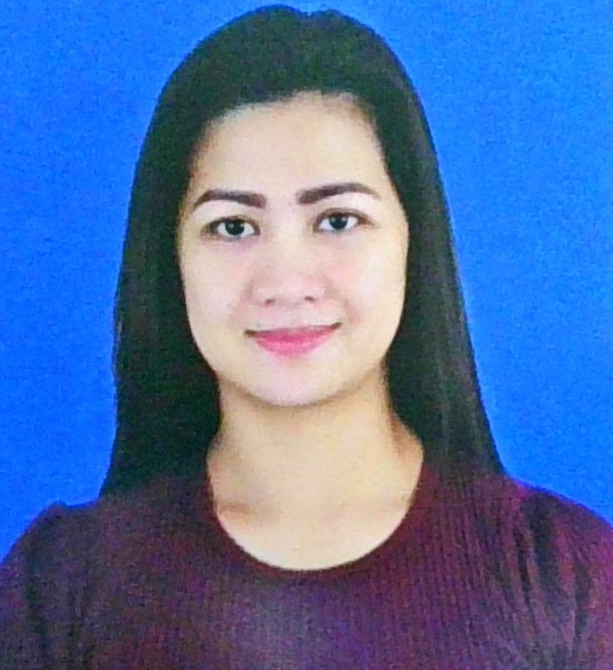 |  | jacqueline christina javier torrecampo  OBJECTIVES:  To secure a suitable position in an organization were  Proven skills and experience could be used productively to enhance Career Development, Professional growth and leads mutual benefits for the organization and the individual.
CONTACT  PHONE NUMBER:  30749783  EMAIL:  torrecampojacqueline@yahoo.com  PLACE;  Doha, Qatar  personal DETAILS  Gender: Female  Status: Single  Height: 5’7 – 167cm.  Weight: 62kg  Passport no: P0462308B  Visa Status: Transferable Visa w/NOC  EDUCATION  Vocational:  SLDM College of Quezon City  Japanese Language & Culture  Housekeeping  S.Y. 2018 – 2019  SECONDARY:  Maligaya High School  S.Y. 1997 – 2001  PRIMARY:  Lagro Elementary School  S.Y. 1991-1997  SKILSS  -Knowledge in Computer, Microsoft Word  -Good interpersonal and communication skills  -Quick learner and efficient in basic computer operation  -Effective Team Player  STRENGTHS  Cultural Understanding, strong work  Ethic, dedication to fulfil objective’s,  Professionalism, trustworthy & loyalty.  LANGUAGE  Tagalog, English and Japanese |  | professional experience  Receptionist  Hello Beauty  Doha Qatar  2024  -Deliver high-quality manicure, pedicure and other  Nail treatments, design and arts for nails.  -Listen to my clients wishes and make recommendation  To help them reach their nail goals.  -Keep all equipment sanitized and in proper working orders.  -Answering all incoming calls and assisting clients with bookings.  -Making detailed notes about services received.  -Helping to maintain general cleanliness around salon  Sales Representative / Sales Lady  We Provide Organic Health Products /Jag Jeans SM Dept. Store  San Juan Ortigas Metro Manila / SM Fairview  2021 – 2023 / 2010-2012  -Selling products to customer and representing brands.  -Concerning about health issue for customer if the products are good for them.  -Asking questions to pinpoint the best offering, giving demos and assurance to maintaining customer relationships.  -Reaching out to potential leads through a variety such a  Emails, phone calls, text and social media.  -Greet customers at the store and ascertain what each customer wants or needs.  -Lead customers to desired shelves or aisles and assist them in locating products.  -Making sure the area is clean and organize  -Re-stocking and make sure all the products are available for customers’ needs.  Office Staff  Zacarias Law Firm  BPI office Roxas Boulevard Macapagal Avenue Phi.  2020  -Carrying out an assigned task.  -Organizing files.  -Creating a welcoming environment.  -Preparing and Cleaning workplace. Maintaining and organising common office areas.  Japanese Language Tutor  TESDA Fairview Quezon City  Quezon City Phi.  2019  -Lead a group of lesson to assist a student studying the  Japanese language.  -Responsibilities to prepare students for specific exams to  Improve their conversational Japanese,  -Responsible for delivering language teaching.  -Fostering cultural understanding and communication.  Production Staff Wedding Box factory  Construction and Interior Site Company  Lagro Quezon City Phi.  2017  -Assemble products and inspect finished products for defects  -Overseeing the project from start to finish.  -Coordinate and organize production schedule activities.  -Perform manual labor tasks in production environment.  -Maintaining the cleanliness of workplace.  Cook / Waitress  Udon House / Filipino & Japanese cuisine  George Bocobo Malate Manila Phi.  2013 – 2016  -Cook plans, prepares and cooking food items to insure  The highest quality service and experience for customer.  -Helping the kitchen to organized and running efficiently.  -Ensure proper food handling, sanitation and following  Food storage procedures.  -Waitress responsibilities include greetings such as warm  Welcome and serving customers.  -Providing detailed information on menus.  -Multi-tasking various front of the house duties and collecting orders  I Hereby certify that the above information is true and correct  To the best of my knowledge and beliefs.  jacqueline christina j.torrecampo  Applicant

