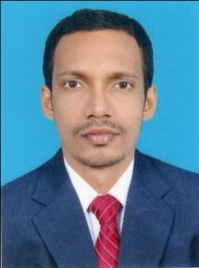

**CURRICULUM VITAE**

Name :**MOHAMMED FAIZAL. M**

Mob :30383819, 55227199

Email : [faizzukarle@gmail.com](mailto:faizzukarle@gmail.com)

**Career Objective**

To build career in a growing organization, where I can get the opportunities to prove my abilities by accepting challenges, fulfilling the organizational goal and climp the career ladder through continuous learning and commitment.

**Academic Qualification**

* Successfully Completed the Degree in B com from Kannur University. Kerala, India.
* Completed the Higher Secondary Education under the State Council of Education board from Kerala, India.
* Completed Secondary Education under the State Council of Education board from Kerala, India.

**Other Qualification**

* Basic in Computer Education.
* MS Office (Word, Excel)
* Users of Internet and Mailing.

**Work Experience**

* Worked 2 Years as a Salesman in Kotayil Sanitary Shop. Kerala, India.
* Worked 1 Year as a Salesman in Campus Footware Kumbla, Kerala, India.
* Worked 2 Years as a Salesman in Kumbol Supermarket. Kerala, India.

**Personal Skills**

* Team work and empowering team Members for Achieving Goals.
* Ability to handle problems impudently and Taking Leadership for the Team.
* Sincere, Self- Disciplined, and Punctual.

**Personal Profile**

Father’s Name : Mohammed

Date of Birth : 08/02/1991

Sex : Male

Marital Status : Single

Language Known : English, Hindi, Malayalam.

Nationality : Indian

Hobies : Listening music, Dance

**Declaration**

I, hereby declare that all the above information’s are true and correct to the best of my knowledge and belief.

**MOHAMMED FAIZAL. M**