CURRICULUM VITAE
AFSHIN THODUVIL  Mob: 74438830  Email: afshinmkd@gmail.com  Doha, Qatar |  | 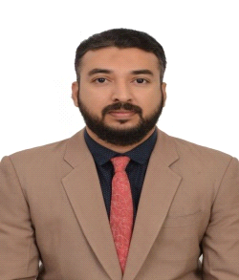

Career Objective
Looking forward for an organization that offers a challenging, stimulating, learning environment to work in suitable field and provide scope for individual and organization devolvement, which offers attractive prospects for long development and career growth.

Work Experience
- Driver cum Office Assistant and Messenger:- Cheque/cash collection ,Deposit, Tender submission to client and delivery in Al Rabban Computer Technology, Doha, Qatar from April 2015 to March 2021 (6 years)

- Site Supervisor cum Driver :- Supervise and purchase for construction site in Buildon company from Sep 2021 to April 2022

- Participated in Fifa World Cup 2022 event as a VIP transportation staff with Pretorian Company

Other info
- I have valid light vehicle Driving License.
- I have transferable VISA.

Educational Qualification
- Higher Secondary Education completed in State Board of Kerala – India.
- Secondary Education in State Board of Kerala – India
- Diploma in Computer Application (DCA) (Govt. of Kerala LBS)

Personal Details
Qatar ID No. | : | 28535655720 | QID Validity | : | 03/04/2025
Passport No. | : | R8307855 | Date of Birth | : | 17/05/1985
Nationality | : | India | Gender | : | Male
Marital Status | : | Married

Language Skill
Language | Speaking | Reading | Writing
English | Excellent | Excellent | Excellent
Hindi | Good | Good | Good
Arabic | Average | Average | Average

Declaration:
I sincerely hope that my application will receive your kind attention and I most anxious that an opportunity for an interview is given to me soon.
Afshin Thoduvil
74438830

