**CURRICULAM VITAE**

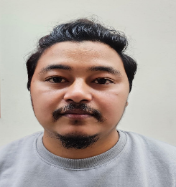

**Raj Kumar Bhattarai**

**Doha-Qatar**

Mob. No: +974 66856925

Email: [rajkumarbhattarai56@gmail.com](mailto:rajkumarbhattarai56@gmail.com)

**Objective**

Desire a position where I can utilize my knowledge and experiences with a career growth potential. I would like to work dedication, determination and enthusiasm to obtain the organizational goals in synchronization with the management. I believe in result- oriented hard work along with quest for self- satisfaction.

**Work Experience**

* **SINOHYDRO CORP. LTD**
* Position : Light Driver
* Period : March 2020 to March 2024

**Responsibilities**

Transportation of Staff & Mangers

**Qualification Highlights**

* High School Passed in Nepal
* Computer Hardware

**Driving License**

* Valid Qatar Driving License.

**Personal Profile**

* Date of Birth : 28/11/1993
* Marital Status : Single
* Nationality : Nepal
* Religion : Hindu
* Languages Known : English, Hindi, Nepali
* Passport detail : No:2226311 (Validity 23/12/2033)
* Visa Status : Transferable with NOC

**Declaration**

I hereby declare that all the details furnished above are to the best of my belief and knowledge.

**Doha – Qatar** **Raj Kumar Bhattarai**