**HELMI MOUEDEB**

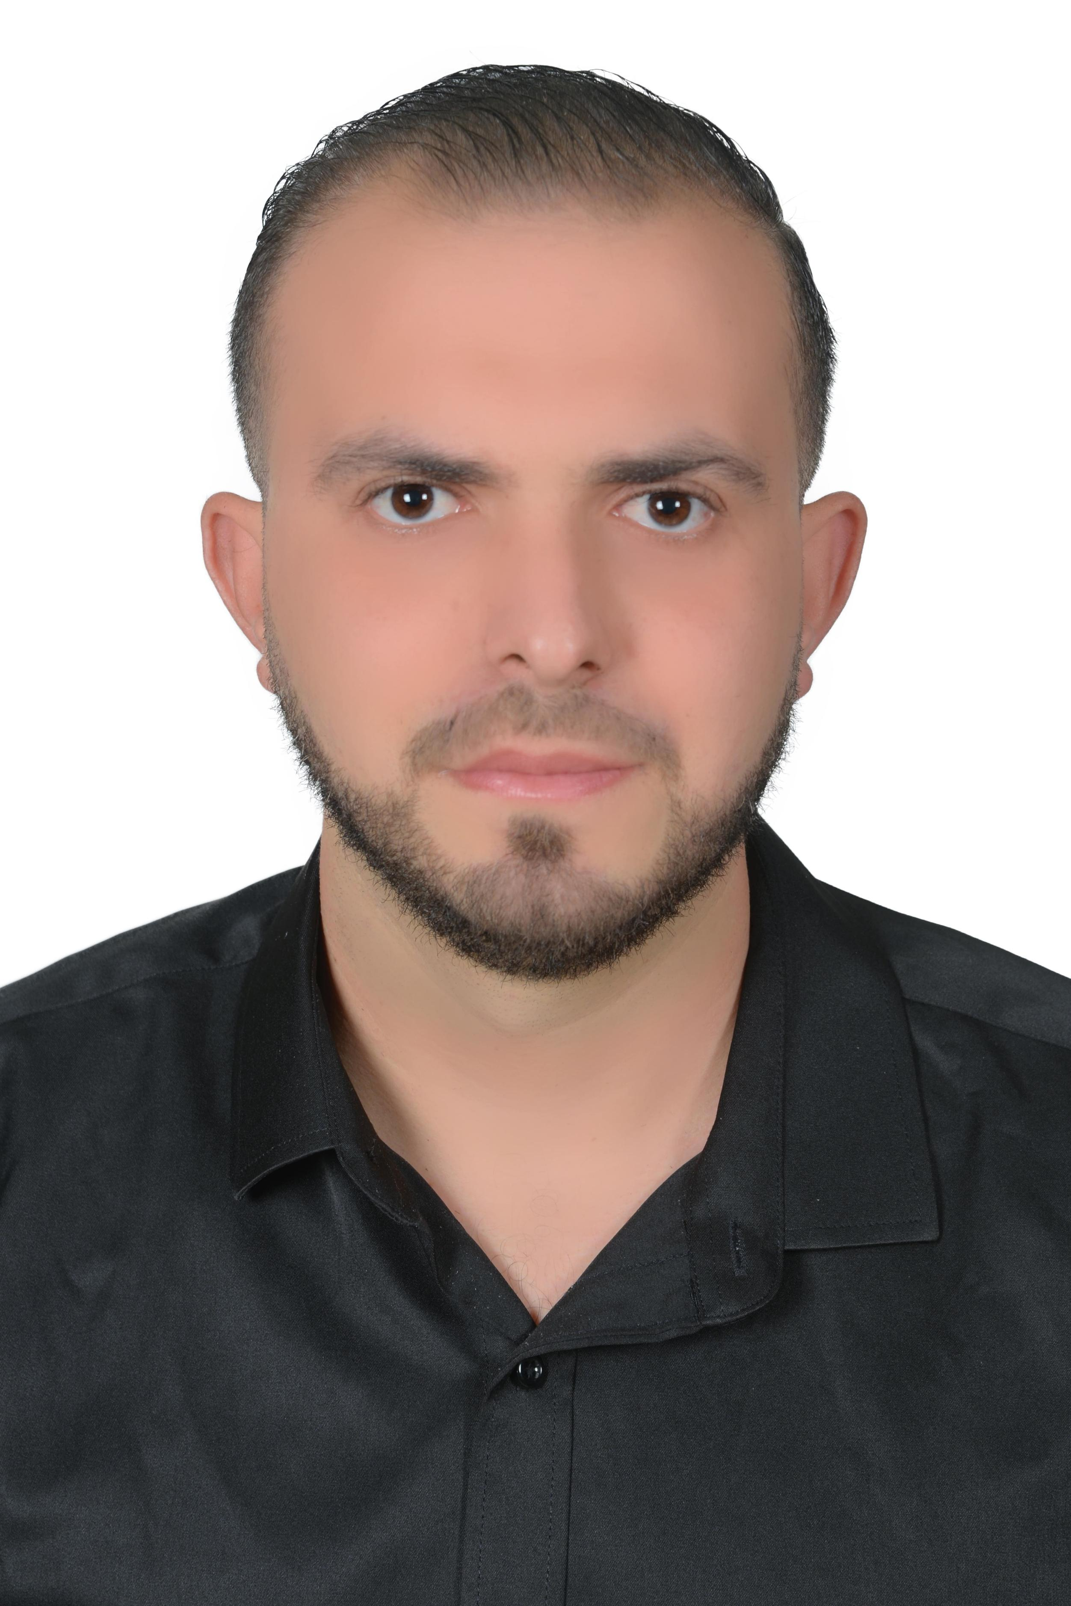

**Sales Executive**

Adress : 7. Massoud Sayah street, Mahdia 5111 | Date of birth : January ,21st 1995

E-MAIL : Meddeb.helmy@gmail.com | Phone Number : +216 24 625 167|

*In*  : @https://www.linkedin.com/in/helmi-mouedeb

**PROFILE SUMMARY**

Dedicated sales executive agent with extensive experience in both frontline and supervisory roles. Skilled in analyzing customer feedback and implementing technology and data-driven insights to enhance customer satisfaction, increase sales, and improve operational efficiency. Expertise in up-selling techniques that drive revenue growth while fostering a positive customer experience. Committed to contributing to the overall success of your organization through strategic sales initiatives and exceptional service

**EDUCATION**

Research masters M1 2017 - 2018

National School of Engineers – Sousse

Specialty : Intelligent road traffic control systems (hit4med)

Fundamental License in Transport and Logistics Sciences 2013 - 2016

Higher Institute of Transport and Logistics – Sousse

Specialty : Modeling and Technology of Logistics and Transport

Baccalaureate 2012-2013

. Ibn Sina Secondary School – Mahdia

Specialty : Experimental sciences (Mention : Good)

**PROFESSIONAL EXPERIENCE**

***Sales Executive, Relax shopping center – Mahdia***

08/ 2024 to Present

* Conducted comprehensive market research to identify and understand potential customer needs.
* Proactively engaged with prospects through calls and networking, while nurturing relationships with existing clients.
* Developed and delivered compelling presentations on products and services to effectively attract and inform customers.
* Successfully closed sales by negotiating favorable terms and addressing client inquiries and concerns.

***Guest Service Agent, Aura Group- World of Wonders park- Qatar***

09/ 2022- 07/ 2024

* Deliver exceptional customer experiences by greeting clients warmly and engaging with them in a friendly, professional manner to foster a welcoming atmosphere.
* Take ownership of customer interactions by providing personalized service and collaborating effectively with team members to meet customer expectations.
* Ensure that all special billing instructions and customer requests are accurately documented and communicated to relevant departments in a timely manner.
* Provide clear and concise information to customers through phone, email, and in-person interactions, ensuring timely responses to inquiries.

***Store Manager, Copharma – Tunisia***

07/ 2020 – 09/ 2022

* Led a team in managing inventory effectively, ensuring timely and accurate stock control to meet customer demands.
* Implemented a computerized inventory management system, enhancing efficiency and accuracy in tracking goods.
* Developed and maintained organized store layouts, improving customer experience by ensuring easy access to products.
* Fostered a customer-centric environment by trainings on best practices in service delivery and product knowledge.

***Voucher Supervisor, LTI Mahdia Beach – Rayar Aqua Park***

03/ 2019 – 12/ 2019

* Conducted thorough quality checks on received vouchers, ensuring compliance with standards and enhancing customer satisfaction.
* Collaborated with suppliers to negotiate solutions during operational challenges
* Monitored sales trends and inventory levels to ensure product availability, contributing to seamless customer service operations.

***Store Keeper, Interdistribution SARL***

01/ 2018 – 02/ 2019

* Managed the reception and verification of products, ensuring accuracy in deliveries .
* Organized and prepared shipments efficiently, maintaining high standards of service for both internal teams and external clients.
* Conducted regular inventory audits to maintain stock rotation and accuracy, ensuring customers received the freshest products available.

**SKILLS & CERTIFICATIONS**

***Technical skills****:*

* Stock Management SAP
* HubSpot for managing customer relationships
* Microsoft PowerPoint
* Microsoft Excel

***Soft Skills*** :

* Team management
* Work under pressure
* Conflict resolution
* Multitasking
* Time management

***Certifications***

* How to ensure an ideal and differentiating customer experience ?

Bpifrance university, 03/08/ 2024

* Decode your clients’ strategy to sell better

Bpifrance university, 03/08/ 2024

* Training in computer science and office skills.

ICF, 05/02/ 2021

**LANGUAGES**

* English :Advanced
* Frensh : Advenced
* Arabic : Native

____________________________________________________________

Reference : Rakesh Annadurai +974 3312 3408 (Other references : upon request).