ABOUT ME:  A dedicated and passionate Electrical Engineer with two years of direct experience at Pal Power Inc, where I contributed effectively to achieving the company’s technical goals. Hold a Bachelor of Electrical Engineering, Class of 2022, reflecting a strong academic foundation that complements my engineering skills. Additionally, I have gained valuable expertise in marketing and sales through working for one and a half with Gravity Company, where I enhanced my ability to build client relationships and drive strategic growth. I am eager to leverage my knowledge and experience to support your team and contribute to realizing your vision.  WORK EXPERIENCE:  Worked for two years from 2018 – 2023 in the field of electric generators and UPS systems at PalPower for Energy & Contracting, gaining experience in this domain. "I also have worked in the field of Uninterruptible Power Supply (UPS) systems, dealing with specific types of systems, such as those produced by the Turkish company Makelsan."  - I worked on providing effective solutions to power outage issues in the Palestinian market by supplying electric generators, batteries, and power regulators, aiming to meet customer needs and ensure a reliable and efficient power supply.  - Developing innovative solutions to power outage issues by designing and selecting appropriate electric generators and UPS systems tailored to customer needs.  - Supervising the installation and operation of electric generators and UPS systems, ensuring their efficiency and reliability.  - Performing regular and preventive maintenance on generators and UPS systems to ensure continuous operation and minimize breakdowns.  - Troubleshooting and resolving technical issues promptly to reduce downtime.  - Providing on-site technical support to clients, including training them on the proper use and maintenance of equipment.  - Monitoring the availability of spare parts and necessary equipment for generators and UPS systems to ensure uninterrupted supply.  Worked as a Sales Representative for a year and a half from 1/8/2023 – 1/12/2024 at Gravity Company where I enhanced my skills in marketing and customer engagement.  - Customer Relationship Management  - Built strong relationships with existing and prospective clients to ensure satisfaction with the company’s products or services.  - Addressed customer inquiries and complaints, providing timely and effective solutions.  2. Sales and Target Achievement  - Developed effective sales strategies to achieve monthly or annual company goals.  - Professionally presented products or services to clients, persuading them to invest in the offered solutions.  3. Marketing and Brand Promotion  - Designed and implemented marketing campaigns to increase brand awareness and attract more clients.  - Contributed to improving marketing strategies by analyzing market needs and competitor activities.  4. Team Collaboration and Leadership  - Collaborated closely with different teams to ensure the achievement of company objectives.  - Provided training or guidance to the sales team to enhance their performance.  5. Exploring New Opportunities  - Identified new markets and targeted potential clients to expand the customer base.  - Contributed to developing future business plans based on market trends.  6. Problem Solving and Negotiation  - Negotiated with clients and suppliers to secure the best deals and pricing.  - Addressed challenges and resolved issues to ensure smooth operations.  7. Enhancing Customer Experience  - Collected customer feedback and used it to improve the quality of products or services.  - Ensured a positive customer experience at all levels of interaction. | 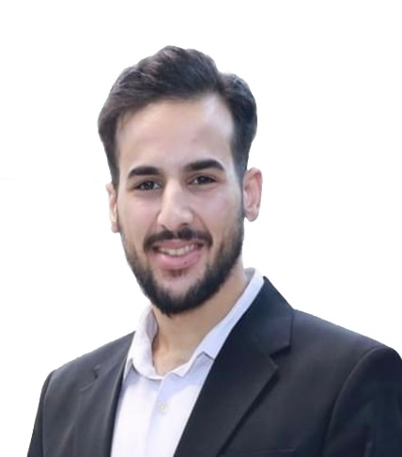  Nour Aldeen Emad Ali Salah  DATE OF BIRTH 10/04/2001  NATINALITYـ: Jordanian  GENDER: Male  CONTACT  Jerusalem- Abu Dees  Palestinian territorires (Home)  Nouremadmoh@gmail.com  +970594610507  https://www.facebook.com/share/18tAHFRJJQ/?mibextid=wwXIfr
EDUCATION AND TRAINING:

2017-2018 Ramallah, Autonomous Palestinian Territories.

Bachelor of Electrical Engineering $ Bilateral Studies. Al-Quds University/ Abu Dees.

01/08/2018 – 01/01/2023 Ramallah, Autonomous Palestinian Territories.

SKILLS:
- possess extensive knowledge in computer systems and technologies, with exceptional skills that set me apart in this field.
- Marketing and Sales: Solid understanding of marketing strategies and developing client relationships to support business growth.
- Teamwork: Ability to work within cross-functional teams, fostering collaboration and productivity.

LANGUAGES:
- Arabic (Native)
- English (C1)

